1. Introduction
Choosing the right career is one of the most important decisions in a student's life, as it significantly influences their future education, professional growth, and personal development. However, many students face difficulties in identifying suitable career paths due to a lack of career guidance, limited awareness of available opportunities, and uncertainty about their skills, interests, and academic performance. These challenges can lead to inappropriate career choices, dissatisfaction, and difficulties in achieving long-term professional goals. Therefore, providing personalized career recommendations has become increasingly important in helping students make informed decisions about their future.
Machine learning has emerged as a powerful technology for analyzing student-related data and identifying patterns that can support intelligent career guidance. In this project, we develop a Personalized Career Recommendation System Using Machine Learning that recommends suitable career paths based on students' academic performance, skills, interests, certifications, projects, and other relevant attributes. The system also aims to support students in making appropriate educational choices after completing Class 10 by helping them explore suitable academic streams and potential career opportunities.
To identify suitable career options, the project involves data preprocessing, exploratory data analysis, feature selection, and model training using a merged student assessment and career compatibility dataset. Different machine learning algorithms, including Random Forest, XGBoost, LightGBM, CatBoost, Logistic Regression, and Decision Tree, can be evaluated to identify an effective model for predicting career compatibility. Appropriate evaluation metrics are used to assess model performance and determine its suitability for generating reliable recommendations.
The proposed system aims to provide personalized, data-driven career suggestions that help students understand their strengths, explore relevant career opportunities, and make better-informed educational and professional decisions. By reducing dependence on generalized career advice, the system seeks to offer recommendations that are more closely aligned with individual student profiles. In the future, the system can be developed into a user-friendly web application that allows students to enter their details and receive personalized career recommendations, along with guidance on relevant skills and educational pathways.

2. Supporting Literature
2.1 Literature Review
Paper 1 – Selvaraj K, Mohamad Adnan M, Vishnupriya K, Mallikarjun Reddy P. AI-Driven Intelligent Career Mapping and Skill-based Job Role Predicting Career Guidance System. Third International Conference on Augmented Intelligence and Sustainable Systems (ICAISS), IEEE, 2025.
This research presents an AI-driven Career Guidance System that predicts suitable career paths based on users' skills and career interests. The system collects user information through structured surveys and questionnaires and applies machine learning techniques to recommend the top three career options. The proposed approach focuses on providing personalized career guidance by matching user skills with career opportunities.
The dataset consists of structured career information, including career fields, job roles, and the corresponding skills required for each profession. Before model training, the collected data undergoes preprocessing steps such as handling missing values, label encoding, multi-label encoding, normalization, and feature engineering to improve prediction accuracy and model performance.
The study uses Random Forest to predict the user's career field and LightGBM to recommend the top three suitable career roles based on the predicted career field and acquired skills. The model is evaluated using performance metrics such as Accuracy, Precision, Recall, F1-Score, and Confusion Matrix. The system also provides a learning roadmap and task completion mechanism to guide users toward their career goals, making the recommendation process more interactive and personalized.
TITLE | AI-Driven Intelligent Career Mapping and Skill-based Job Role Predicting Career Guidance System
AREA OF WORK | Develops an AI-based career guidance system that predicts suitable career paths based on user skills and career interests through personalized questionnaires.
DATASET | Structured dataset containing career fields, job roles, and required skills collected for career prediction and recommendation.
METHODOLOGY | User survey and questionnaire, data preprocessing, feature engineering, label encoding, multi-label encoding, Random Forest-based career field prediction, and LightGBM-based career recommendation.
ALGORITHMS | Random Forest, LightGBM
RESULTS | Successfully predicts the top three suitable career roles based on users' skills and career interests, providing personalized career guidance.
ADVANTAGES | Provides personalized recommendations, incorporates skill-based prediction, includes a career roadmap, and improves user engagement through task tracking.
FUTURE PROPOSAL | Can be extended by integrating real-time job market information, larger datasets, and additional machine learning models to further improve prediction accuracy.
Table 2.1 Literature Review Summary – I

Paper 2 – Guntupalli U.G.S., Veeranki D.T., Pandala M.L., Kumbha P. Career Compass: A Career Path Recommender using Machine Learning. 5th International Conference on Electronics and Sustainable Communication Systems (ICESC), IEEE, 2024.
This research proposes a personalized career recommendation system that predicts suitable career paths based on an individual's skills, interests, and personality traits. The study addresses the limitations of traditional career guidance by introducing a dynamic questionnaire that adapts according to user responses, allowing a more personalized assessment. The system is implemented as a mobile application to provide an interactive and user-friendly platform for students seeking career guidance.
The dataset used in the study contains information related to career paths, required skills, and personality traits. It also incorporates the Big Five personality questionnaire to evaluate individual characteristics. Data preprocessing includes cleaning the dataset, selecting relevant features, and preparing the data for training machine learning models.
The proposed system employs Random Forest and Support Vector Machine (SVM)
algorithms to predict suitable career paths. The Random Forest model achieved better performance than the SVM model in terms of accuracy, precision, and recall. The study concludes that integrating skills, interests, and personality through a dynamic questionnaire improves the effectiveness of career recommendations and helps students make informed career decisions.
TITLE | Career Compass: A Career Path Recommender using Machine Learning
AREA OF WORK | Develops a personalized career recommendation system using a dynamic questionnaire to evaluate students' skills, interests, and personality traits.
DATASET | Career dataset containing skills, career paths, and personality information integrated with the Big Five personality questionnaire.
METHODOLOGY | Data preprocessing, feature selection, dynamic questionnaire, model training, mobile application development, and performance evaluation.
ALGORITHMS | Random Forest, Support Vector Machine (SVM)
RESULTS | Random Forest achieved higher accuracy and better overall performance than the SVM model for career prediction.
ADVANTAGES | Provides personalized career recommendations through a dynamic questionnaire and interactive mobile application.
FUTURE PROPOSAL | Integrate real-time job market information, psychometric assessments, and additional career guidance features to improve recommendation quality.
Table 2.2 Literature Review Summary – II
Paper 3 – Siswipraptini P.C., Warnars H.L.H.S., Ramadhan A., Budiharto W. Personalized Career-Path Recommendation Model for Information Technology Students in Indonesia. IEEE Access, 2024.
This paper presents a personalized career-path recommendation model designed specifically for Information Technology students. The authors observe that students often select career specializations based on subjective opinions from friends or family rather than objective guidance. To address this issue, the study proposes a web-based recommendation system that combines educational data, personality analysis, and career information to recommend suitable IT career paths. The system aims to assist students in making informed career decisions by considering multiple aspects of their academic and personal profiles.
The proposed framework integrates information from several sources, including academic records, subject profiles, job profiles, industry requirements, and personality assessments. Educational Data Mining (EDM) and Grounded Theory (GT) techniques are employed to extract and organize relevant information from these data sources. The system also incorporates the Myers–Briggs Type Indicator (MBTI) personality assessment to understand students' interests and preferences, allowing recommendations to be tailored according to their personality characteristics.
To generate career recommendations, the study uses a personalized Naïve Bayes algorithm that maps student profiles with suitable career paths. The recommendation model is implemented as a web-based application and validated through expert evaluation involving Information Technology professionals and psychologists. User feedback indicates that the proposed model effectively supports students in selecting career paths that match their interests, personality, and educational background. The study reports that more than 83% of respondents were satisfied with the recommendations provided by the system.
The authors conclude that integrating educational data, personality information, and industry knowledge significantly improves the quality of career recommendations. They suggest extending the framework by incorporating additional educational resources, expanding the dataset, and supporting career recommendations in domains beyond Information Technology to make the system more comprehensive and applicable to a wider range of students.

TITLE | Personalized Career-Path Recommendation Model for Information Technology Students in Indonesia
AREA OF WORK | Develops a personalized career recommendation model for IT students using educational data and personality analysis.
DATASET | Academic records, job profiles, subject profiles, personality assessment data, and industry requirements collected from multiple educational and professional sources.
METHODOLOGY | Educational Data Mining (EDM), Grounded Theory (GT), data integration, personality assessment, personalized recommendation model, and web-based implementation.
ALGORITHMS | Personalized Naïve Bayes (p-NB)
RESULTS | The proposed recommendation model achieved high user satisfaction and successfully recommended suitable IT career paths based on students' profiles.
ADVANTAGES | Integrates academic information, personality assessment, and educational data to provide personalized and reliable career recommendations.
FUTURE PROPOSAL | Extend the recommendation framework with additional educational resources, larger datasets, and broader career domains beyond Information Technology.
Table 2.3 Literature Review Summary – III

2.2 Literature Review Summary
TITLE | SUMMARY
Selvaraj et al.  Kailasam Selvaraj, Mohamad Adnan M., Vishnupriya K., Mallikarjun Reddy P. AI-Driven Intelligent Career Mapping and Skill-based Job Role Predicting Career Guidance System. ICAISS; 2025. | The paper presents an AI-based career guidance system that predicts the top three career paths using user skills and career interests collected through questionnaires. It applies data preprocessing, feature engineering, Random Forest for career field prediction, and LightGBM for career recommendation. The system also provides a career roadmap and task tracking to support users in achieving their career goals.
Guntupalli et al.  Umesh Guru Sai Guntupalli, Dharma Teja Veeranki, Madhavi Latha Pandala, Pramodhini Kumbha. Career Compass: A Career Path Recommender using Machine Learning. ICESC; 2024. | This paper proposes a personalized career recommendation system based on a dynamic questionnaire that evaluates students' skills, interests, and personality traits. The system uses Random Forest and Support Vector Machine (SVM) for career prediction, with Random Forest providing better performance. The study highlights the importance of combining skills, interests, and personality to improve recommendation accuracy.
Siswipraptini et al.  Puji Catur Siswipraptini, Harco Leslie Hendric Spits Warnars, Arief Ramadhan, Widodo Budiharto. Personalized Career-Path Recommendation Model for Information Technology Students in Indonesia. IEEE Access; 2024. | The study introduces a web-based personalized career recommendation model for Information Technology students. It integrates academic information, personality assessment, Educational Data Mining (EDM), and Grounded Theory (GT) techniques to generate personalized career recommendations using a Naïve Bayes model. The evaluation reported high user satisfaction, demonstrating the effectiveness of combining educational and personality information for career guidance.
Table 2.4 Overall Summary of Literature Review

2.3 Findings and Proposals
The collective insights from the three reviewed studies demonstrate that Machine Learning is an effective approach for providing personalized career recommendations by analyzing multiple student attributes. The reviewed papers emphasize that considering academic performance alone is insufficient for accurate career guidance. Instead, combining academic information with skills, interests, aptitude, and personality traits results in more reliable and personalized career recommendations. They also highlight the importance of data preprocessing, feature selection, and user profiling in improving the performance of recommendation systems.
From Selvaraj et al. (2025), the key finding is that integrating user skills and career interests with machine learning techniques enables accurate career prediction. Their system employs questionnaires, feature engineering, and machine learning models to recommend suitable career roles while providing personalized career guidance. The study demonstrates that collecting structured user information significantly improves the quality of career recommendations.
From Guntupalli et al. (2024), the major contribution is the use of a dynamic questionnaire that evaluates users' skills, interests, and personality traits before generating career recommendations. Their study shows that combining these factors with machine learning algorithms, particularly Random Forest, improves prediction performance and provides more personalized career guidance compared to relying solely on academic information.
From Siswipraptini et al. (2024), the significant finding is that integrating academic information, personality assessment, and educational data mining techniques enhances the quality of career recommendations. The study also demonstrates that incorporating personality traits into the recommendation process improves user satisfaction and helps students select career paths that better match their interests and abilities.
Taken together, these findings highlight the importance of combining academic performance, skills, interests, and aptitude assessment to improve career recommendations. Based on these observations, the proposed Personalized Career Recommendation System Using Machine Learning analyzes a student's overall profile using machine learning techniques to recommend the most suitable career path. The system aims to provide personalized and reliable career guidance, helping students make informed career decisions.

3. System Analysis
3.1 Analysis of the dataset
3.1.1 About the dataset
The Student Career Recommendation Dataset is used to develop the Personalized Career Recommendation System Using Machine Learning. It contains student-related information, career details, academic characteristics, and compatibility measures that help determine whether a particular career is suitable for a student. The dataset supports the analysis of relationships between student profiles and different career options.
Dataset Link: https://www.kaggle.com/datasets/arjun666007/career-prediction-dataset
Size: The dataset contains approximately 50,689 records and 22 columns in the uploaded CSV file. Each record represents information associated with a student and a career option. The dataset includes numerical and categorical attributes that describe student characteristics, career categories, and compatibility-related factors.
Data Structure: The dataset contains student features such as age, class, and stream, along with career-related attributes such as career domain, subdomain, and career cluster. It also includes matching features related to ability, interest, academic performance, and learning characteristics. Additional alignment measures help represent the relationship between a student's profile and a particular career. The target variable, compatibility_label, indicates whether a career is compatible with the student's profile. The student_id is used for grouping records during dataset splitting and is excluded from the prediction features.
Sparsity: The dataset contains missing values in selected student, academic, and career-related attributes. These missing values are identified and handled during preprocessing using appropriate techniques. Duplicate records and data types are also checked to improve data quality. Numerical and categorical features are processed using suitable transformation techniques before model training. These preprocessing steps prepare the dataset for machine learning and support reliable career compatibility prediction.

3.1.2 Explore the Dataset
A) Statistical Analysis
a) Dataset Overview
The Student Career Recommendation Dataset consists of 50,689 records and 22 columns, containing student information, career details, and student-career compatibility measures. The dataset is used to identify relationships between students' academic backgrounds, abilities, interests, and potential career options.
- Total Records: 50,689
- Total Features: 21 columns other than the target variable, compatibility_label, including identifiers.
- Data Types: The dataset contains a combination of numerical and categorical attributes. Features such as ability_interest_gap, min_core_match, and holistic_synergy are stored in numerical formats, while attributes such as age, class, matching components, stream, and career-related fields are stored as object data types and require appropriate preprocessing.
- Missing Values: Missing values are present in several columns, particularly class, matching components, age, stream, and career-related attributes. The target variable compatibility_label contains 5 missing values, which must be handled before model training.
Feature Categories:
- Identifiers: student_id and career_id identify student records and associated career options.
- Student Characteristics: age, class, and stream describe the student's age, educational level, and academic background.
- Matching Components: ability_match_component, interest_match_component, academic_match_component, and learning_match_component represent the alignment between student characteristics and career requirements.
- Career Information: career_name, career_domain, career_subdomain, and career_cluster describe the career options considered by the system.
- Alignment Features: composite_alignment_index, ability_interest_synergy, ability_interest_gap, min_core_match, max_core_match, harmonic_core_match, geometric_core_synergy, and holistic_synergy represent different measures of student-career compatibility.
- Target Variable: compatibility_label indicates whether a career is compatible with a student's profile, with 1 representing Compatible and 0 representing Incompatible.
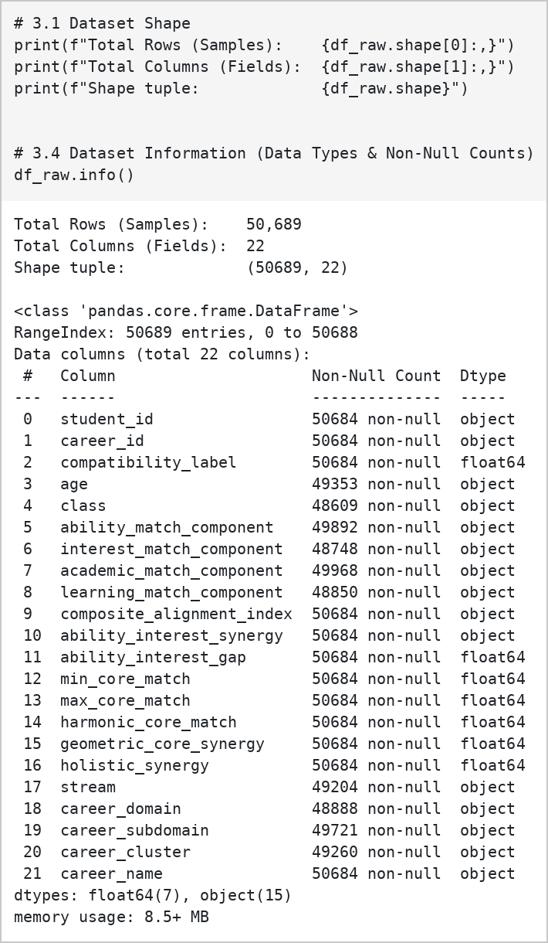
Fig. 3.1: Shape and Data Types of the Dataset
The dataset contains a mixture of numerical and categorical attributes. Several features that represent student characteristics and matching components are stored as object data types, even though some may contain numerical values. These columns require appropriate data type conversion and preprocessing before statistical analysis and machine learning. Missing values must also be handled carefully to ensure that the dataset is suitable for training and evaluating the career compatibility prediction models.
b) Dataset Sample Records
The first five records of the dataset provide an overview of the student information, career details, and compatibility measures available for analysis. Each record includes attributes such as student ID, career ID, age, class, stream, career domain, and matching components. The compatibility_label indicates whether the selected career is compatible with the student's profile.
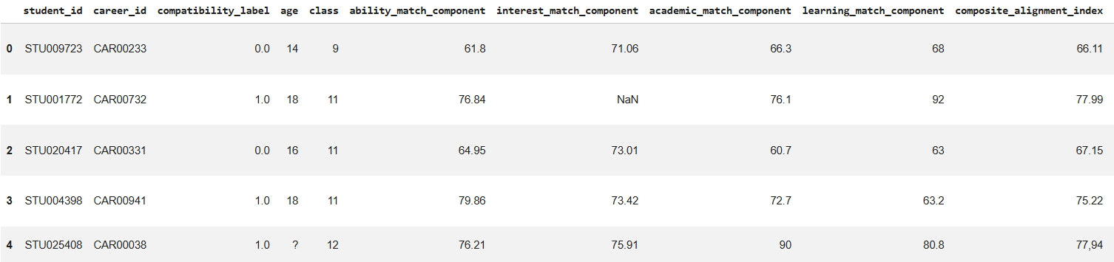
Fig. 3.2: First Five Rows of the Dataset
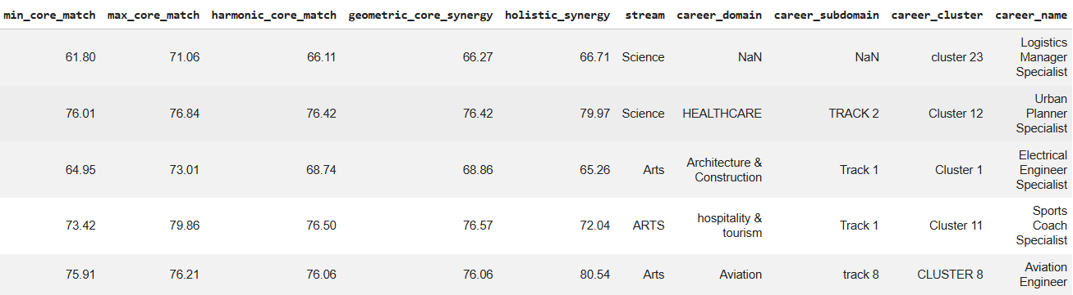
Fig. 3.3: First Five Rows of the Dataset – Continuation
c) Descriptive Statistics (Numerical Features)
Descriptive statistics generated using df.describe() summarize the distribution of the numerical features. The dataset contains compatibility and alignment measures such as ability_interest_gap, min_core_match, max_core_match, harmonic_core_match, geometric_core_synergy, and holistic_synergy. For example, the mean of holistic_synergy is approximately 71.34, while the mean of ability_interest_gap is approximately 7.22. These statistics help understand the central values, variation, and range of the student-career matching features.
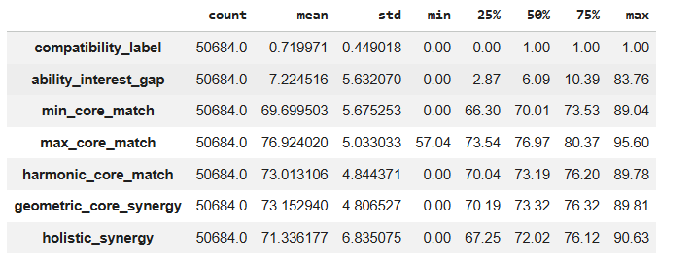
Fig. 3.4: Descriptive Statistics of the Dataset
d) Missing Values Analysis
Missing value analysis identifies incomplete records and columns that require preprocessing. The dataset contains missing values in several attributes. The class column has 2,080 missing values, followed by interest_match_component with 1,941 and learning_match_component with 1,839 missing values. Other affected attributes include career information, student age, and matching components. The target variable compatibility_label contains five missing values. These missing values must be handled appropriately before training the machine learning models.
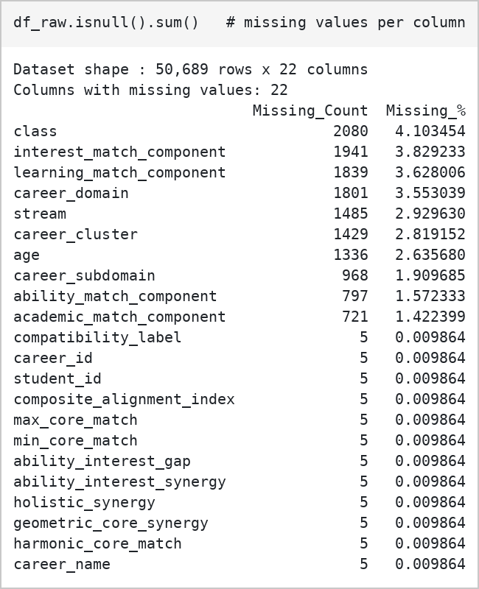
Fig. 3.5: List of Missing Values in the Dataset
e) Target Variable Distribution (Raw Table)
The target variable, compatibility_label, represents whether a career is compatible with a student's profile. The dataset contains 36,491 records labelled 1 (Compatible) and 14,193 records labelled 0 (Incompatible), along with five missing target values. This indicates that compatible records are more frequent than incompatible records in the original dataset. The distribution is examined to understand the class balance and determine whether additional preprocessing is required before model training.
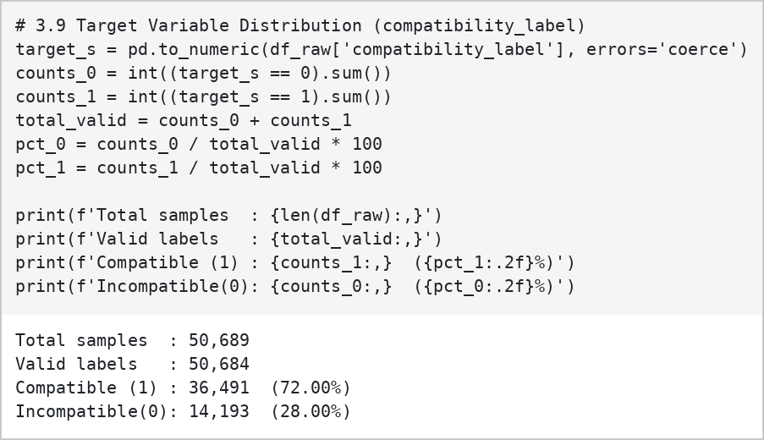
Fig. 3.6: Raw Target Variable Distribution in the Dataset
B) Data Visualization Analysis
a) Compatibility Label Distribution
The compatibility label distribution illustrates the number of compatible and incompatible student-career records in the dataset. The analysis shows that compatible records are more frequent than incompatible records. This visualization helps understand the distribution of the target variable and identify class imbalance before training the machine learning models.
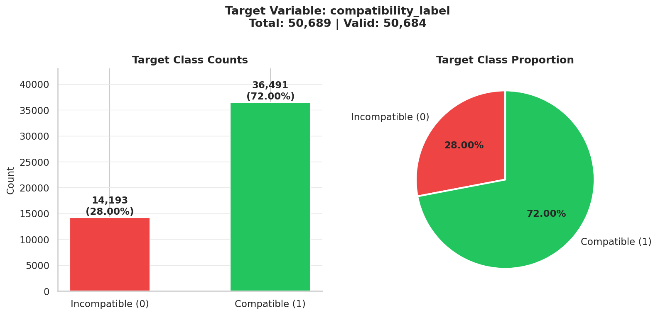
Fig. 3.7: Compatibility Label Distribution
b) Academic Class Distribution
The academic class distribution shows how student records are distributed across different educational levels. This analysis helps identify the representation of students from different classes and understand the educational backgrounds included in the dataset.
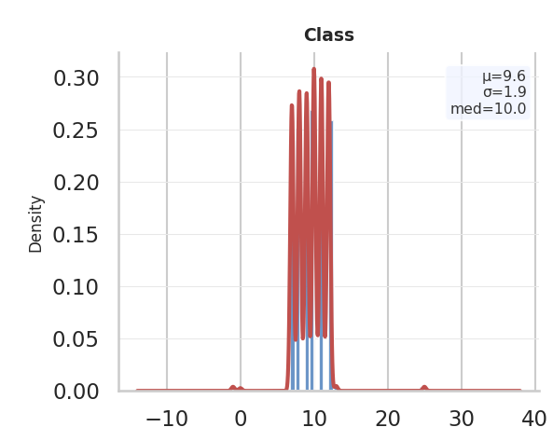
Fig. 3.8: Academic Class Distribution
c) Student Age Distribution Across Grades
The age distribution visualization examines the variation in student ages across different academic grades. It helps identify the age groups represented in the dataset and understand the relationship between students' ages and their educational levels.
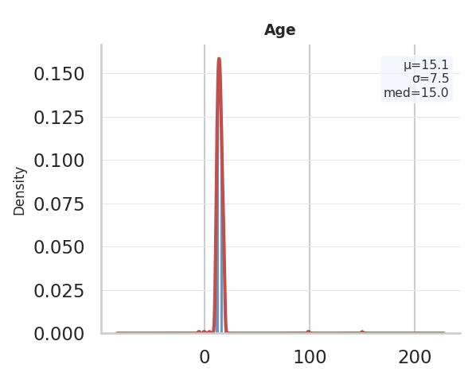
Fig. 3.9: Student Age Distribution
d) Academic Stream Distribution
The academic stream chart presents the compatibility rate observed for each academic stream value, with the number of records shown above each bar. The raw stream labels contain spelling variants and placeholder values (for example, misspelt Science, Arts and Commerce entries, as well as null and unknown values), which confirms the need for the text-cleaning steps applied during preprocessing.
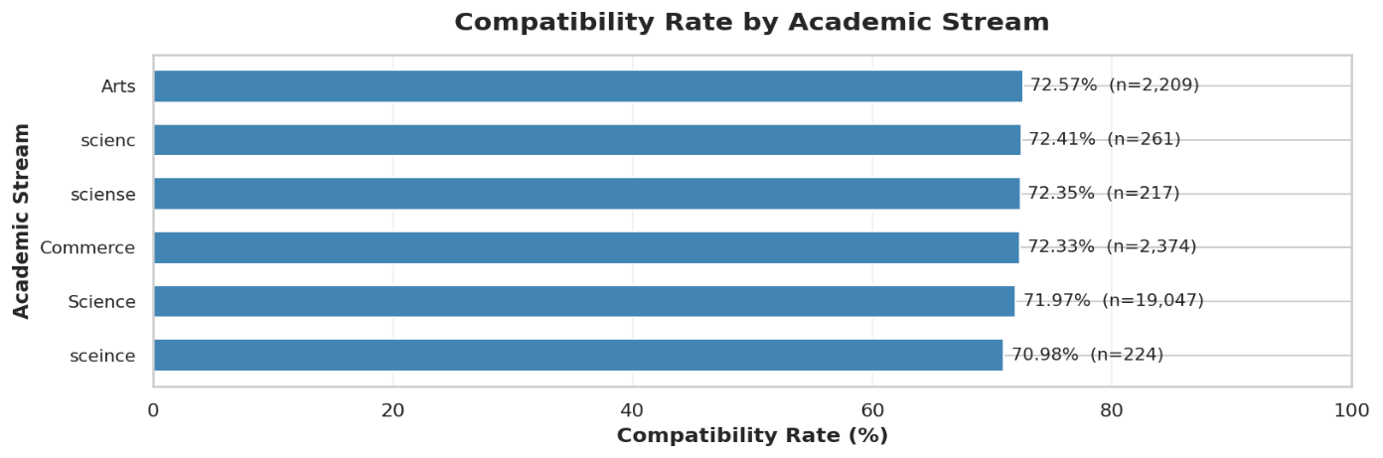
Fig. 3.10: Compatibility Rate by Academic Stream
e) Career Domain Distribution
The career domain chart presents the compatibility rate for each career domain together with the number of records in that domain, and marks the overall average compatibility rate of 71.9%. It provides an overview of the career fields covered by the system and shows that compatibility rates vary across domains, from about 65% for Skilled Trades to about 78% for Arts & Design.
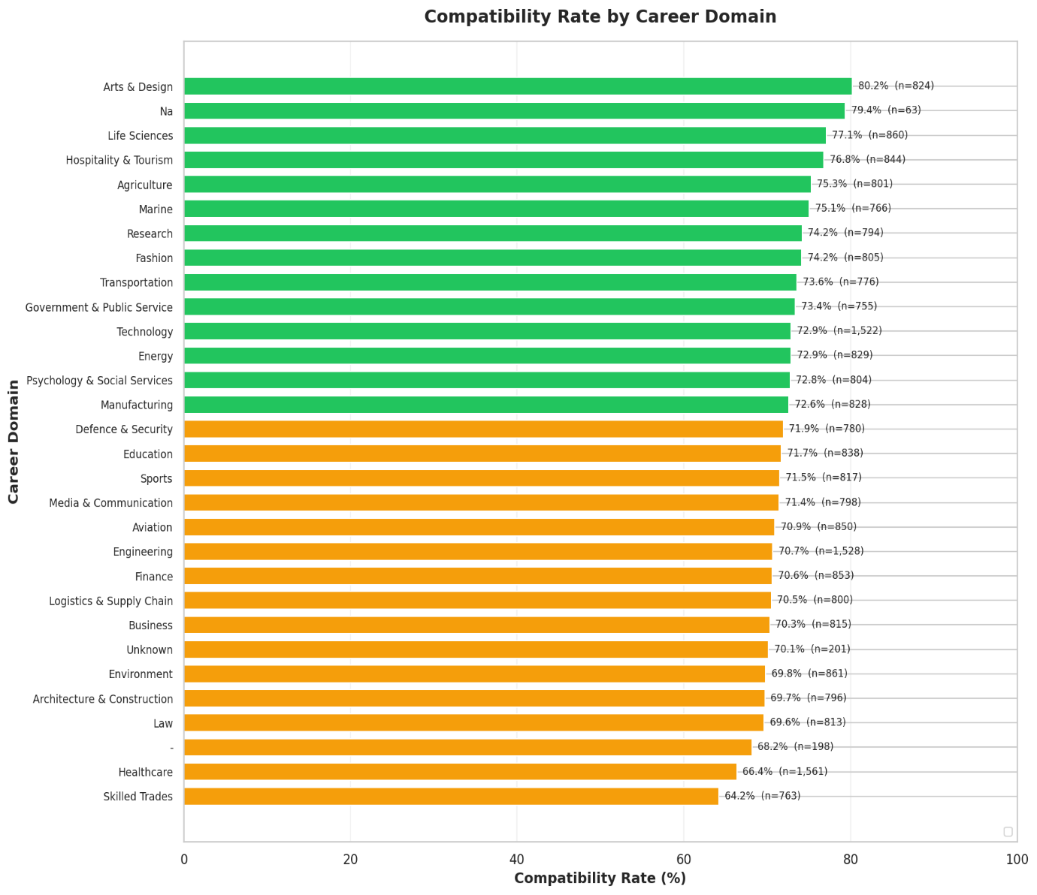

Fig. 3.11: Compatibility Rate by Career Domain

f) Missing Values Analysis
The missing values visualization highlights the columns containing incomplete data. It helps identify attributes that require preprocessing before machine learning. Handling these missing values appropriately improves data consistency and prepares the dataset for model training.
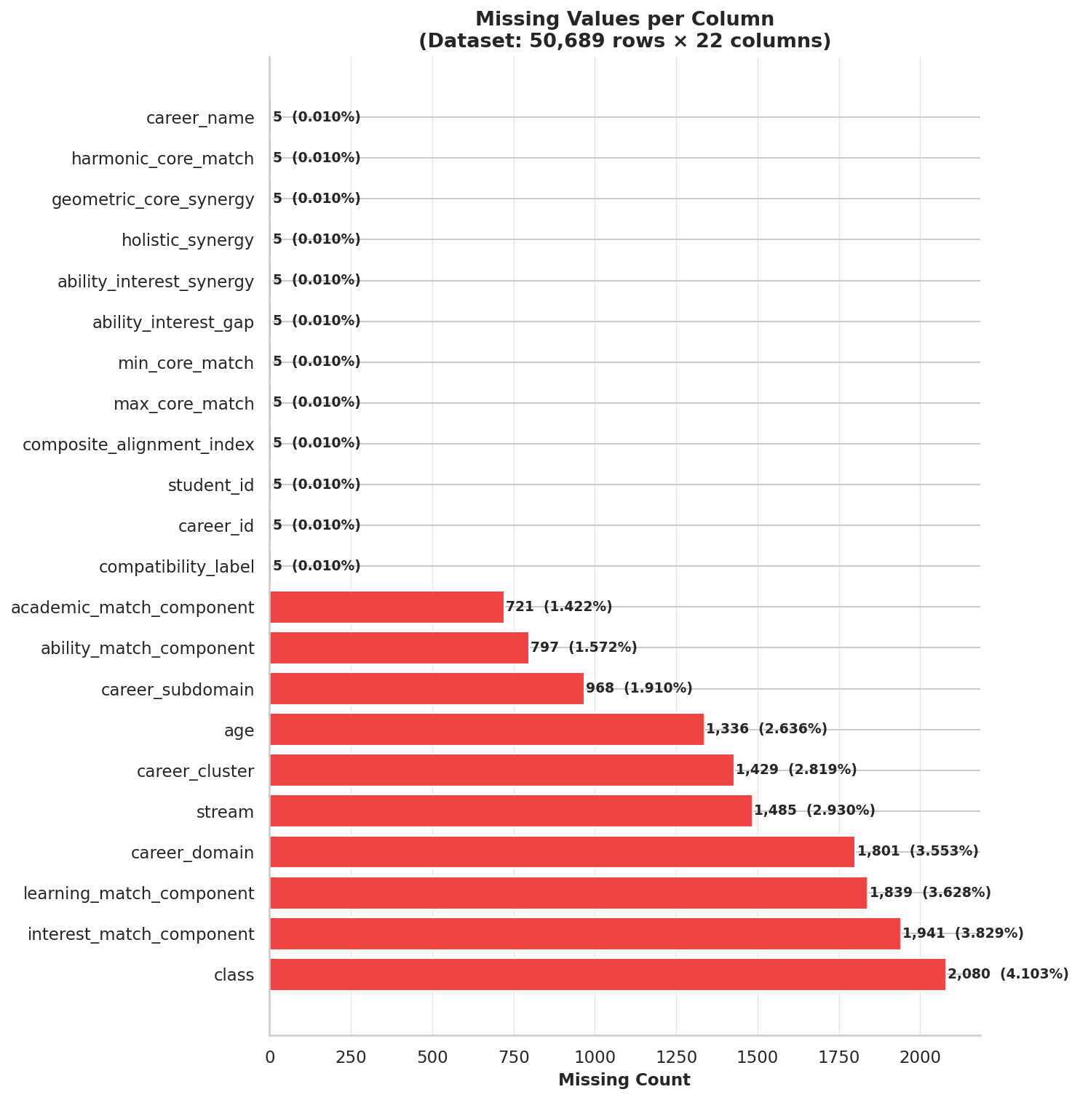
Fig. 3.12: Missing Values Analysis
C) Insights and Conclusions of EDA
The exploratory data analysis of the Student Career Recommendation Dataset revealed important characteristics of the student-career compatibility data. The dataset contains student information, academic attributes, career categories, and matching components that collectively help evaluate the suitability of different career options.
The compatibility label distribution showed that compatible records were more frequent than incompatible records. This difference was considered during preprocessing and model development to ensure that the class distribution was properly handled.
The analysis of academic classes and student ages provided an understanding of the educational levels and age groups represented in the dataset. These attributes help describe students' academic backgrounds and support the development of career recommendations appropriate to their profiles.
The academic stream and career domain visualizations demonstrated the variety of educational backgrounds and career fields represented in the dataset. This is important for a personalized recommendation system because students from different streams may have different interests, abilities, and potential career paths.
Missing value analysis identified incomplete attributes that required attention during preprocessing. Appropriate handling of missing values, data type conversion, categorical encoding, and numerical feature processing helped prepare the dataset for machine learning.
The analysis also highlighted the importance of matching and alignment features, including ability match, interest match, academic match, and learning match components. These features provide information about how well a student's characteristics align with a particular career. Combined alignment measures offer additional information for evaluating student-career compatibility.
Overall, exploratory data analysis provided a foundation for selecting relevant features and preparing the dataset for model training. The findings supported the development of the Personalized Career Recommendation System using machine learning algorithms.
3.2 Data Preprocessing
3.2.1 Data Cleaning
Data cleaning is an important step in preparing the Student Career Recommendation Dataset for machine learning. The original dataset contains missing values, numerical attributes stored as object data types, and categorical features that require suitable transformation. The following operations are performed to improve data quality and prepare the dataset for model training.
a) Numeric Conversion and Dataset Preparation
- Converted numerical features stored as object data types into appropriate numeric formats.
- Handled invalid or unrecognized values during numeric conversion.
- Identified the columns required for student-career compatibility prediction.
- Excluded identifier columns such as student_id and career_id from the prediction features to avoid using identifiers as direct predictors.
- Retained relevant student, career, matching, and alignment attributes for further analysis.
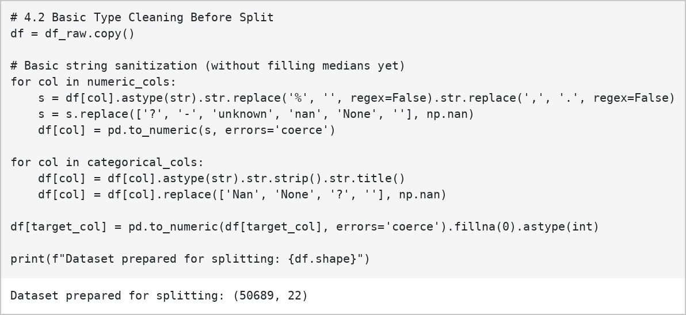
Fig. 3.13: Numeric Conversion and Dataset Preparation
b) Data Type Conversion
The dataset contains attributes such as age, class, and matching components that may be stored as object data types. These features are converted into suitable numerical formats wherever appropriate. Categorical attributes, including stream and career-related categories, are retained for categorical preprocessing.
This step ensures that the features are represented consistently and can be processed by the machine learning pipeline.
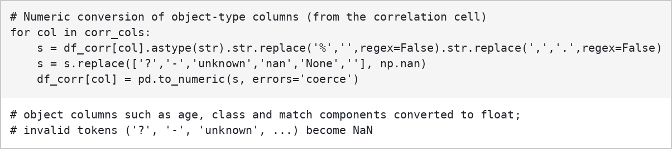
Fig. 3.14: Data Type Conversion
c) Missing Value Handling
Missing values are identified using the dataset's null-value analysis. Several columns contain incomplete records, including class, interest_match_component, learning_match_component, career_domain, stream, and age.
- Missing target values in compatibility_label are excluded from supervised model training.
- Missing numerical values are handled using suitable numerical imputation.
- Missing categorical values are handled using suitable categorical imputation.
- The preprocessing pipeline applies the required transformations consistently to the training, validation, and testing data.
These operations help retain useful records while reducing the impact of incomplete data.
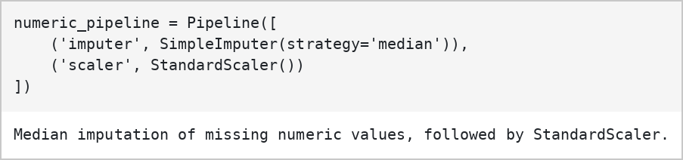
Fig. 3.15: Missing Value Handling (Numerical Pipeline)
d) Duplicate Records and Outlier Analysis
Duplicate records are checked to determine whether identical rows are present in the dataset. The notebook also uses boxplots and the Interquartile Range (IQR) method to examine the distribution of numerical features and identify potential outliers.
Features such as ability_match_component, interest_match_component, academic_match_component, ability_interest_gap, and holistic_synergy are examined to understand their variation. The outlier analysis helps identify unusual values that may require further investigation.
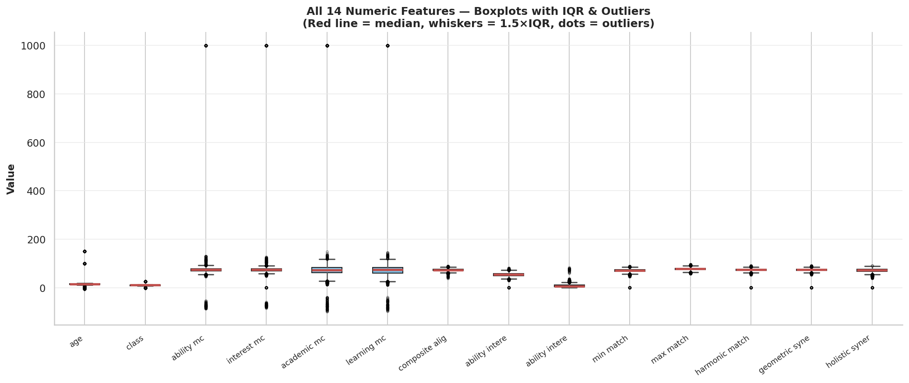
Fig. 3.16: Outlier Detection Using Boxplots
e) Feature Preparation
The dataset includes features representing student characteristics, career information, and student-career alignment. Relevant features are selected for model training, while identifiers are excluded from prediction.
The selected features include age, class, stream, career information, and matching components related to ability, interest, academics, and learning. The alignment features provide additional information about the relationship between student characteristics and career requirements.
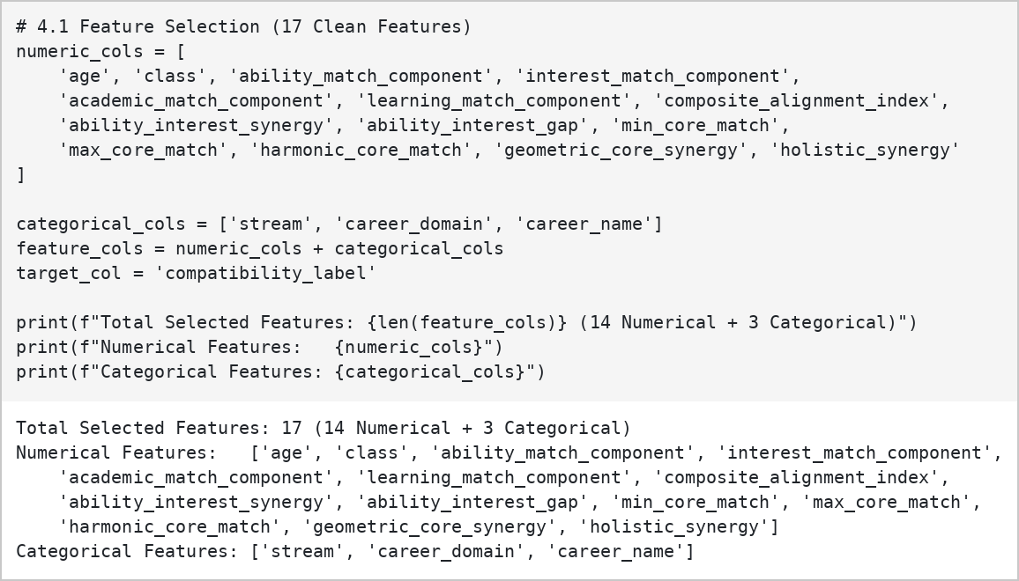
Fig. 3.17: Selected Features for Model Training
f) Target Variable Preparation
The target variable, compatibility_label, is used to train the machine learning models.
- 1 – Compatible: The career is classified as compatible with the student's profile.
- 0 – Incompatible: The career is classified as incompatible with the student's profile.
Records with missing target labels are excluded from supervised learning. The target variable is converted into a suitable numerical format for classification. In the notebook, compatibility_label is additionally reconstructed as a weighted composite of seven standardized alignment features (composite_alignment_index, ability_interest_synergy, geometric_core_synergy, harmonic_core_match, holistic_synergy, min_core_match and max_core_match) with a small Gaussian noise term (sigma = 0.30), thresholded at the 28th percentile so that the original 72% / 28% class balance is preserved. The best single-feature threshold rule reaches only 88.79% agreement with this label, so the models still have to learn a multi-factor combination.
g) Encoding Categorical Features
Categorical features such as stream and career-related categories must be converted into a numerical representation before they can be used by the machine learning models. The notebook uses One-Hot Encoding to represent categorical values as binary columns.
One-Hot Encoding creates separate columns for the categories of a feature. This allows the models to process categorical information without assigning an artificial numerical order to the categories. The encoder is fitted as part of the preprocessing pipeline and then applied consistently to the other data splits.
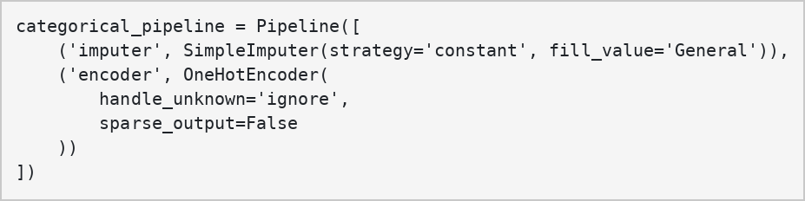
Fig. 3.18: Encoding Categorical Features
h) Numerical Feature Processing
Numerical features are processed using the numerical preprocessing pipeline. Missing numerical values are handled through imputation, and StandardScaler is included to standardize numerical features where required.
Standardization transforms numerical features to a common scale, helping prevent differences in feature ranges from unnecessarily affecting algorithms that are sensitive to scale. The preprocessing pipeline ensures that the same transformations are applied during model training and prediction.
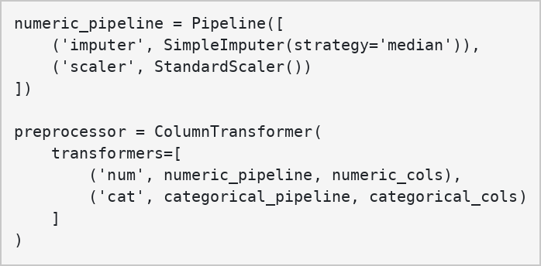
Fig. 3.19: Numerical Feature Preprocessing
i) Handling Class Imbalance
The distribution of compatibility_label is examined to determine whether the compatible and incompatible classes are represented equally. The notebook uses the Synthetic Minority Over-sampling Technique (SMOTE) to address class imbalance in the training data.
SMOTE generates synthetic examples for the minority class to improve class representation. It is applied only to the training data, while the validation and test datasets remain unchanged. This helps maintain an independent evaluation of model performance. In the training set, SMOTE increased the incompatible class from 11,367 to 29,195 records, so that both classes contain 29,195 samples (58,390 in total).
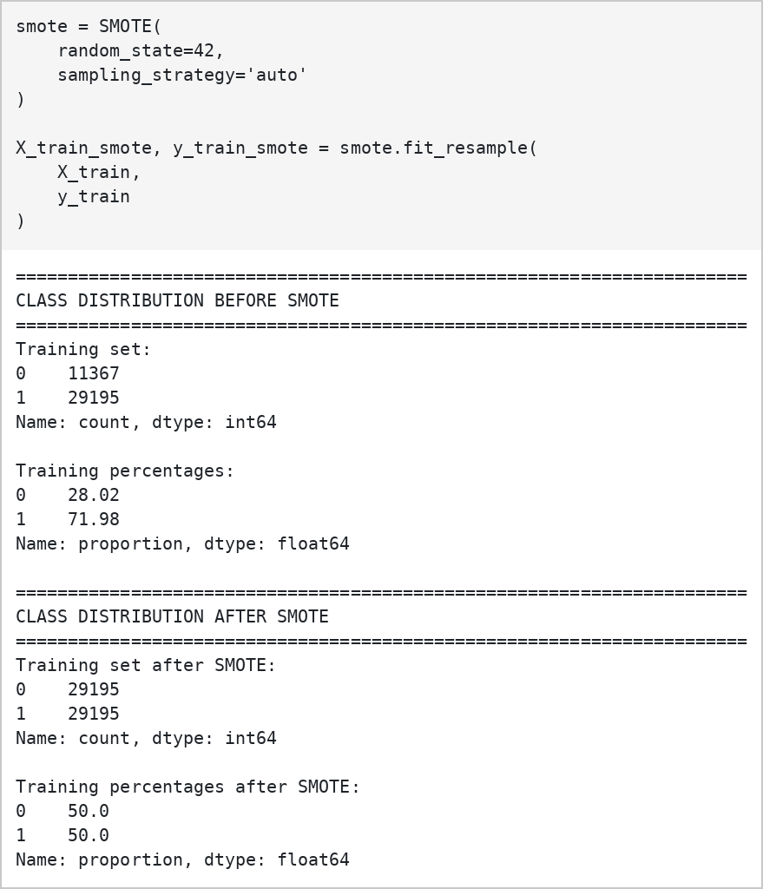
Fig. 3.20: Class Distribution Before and After SMOTE
j) Final Dataset Preparation
After data cleaning, feature selection, imputation, encoding, and numerical processing, the dataset is prepared for machine learning. The target labels are separated from the input features, and the data is divided into training, validation, and testing sets using the student-level splitting approach implemented in the notebook.
The training data is used to fit the models, the validation data supports model comparison, and the test data is used for final performance evaluation. The prepared data is then used to train and compare Random Forest, LightGBM, and XGBoost classifiers.
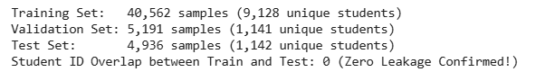
Fig. 3.21: Final Dataset Preparation for Model Training
3.2.2 Analysis of Feature Variables
Feature analysis involves identifying the attributes that provide useful information for predicting student-career compatibility. The dataset contains several types of features, but their relevance to the target variable differs. Analyzing these variables helps understand the dataset and supports the development of an effective prediction model.

A) Correlation Analysis
Correlation analysis is used to examine the relationships among numerical features and the target variable, compatibility_label. A correlation coefficient ranges from −1 to +1.
- A value close to +1 indicates a strong positive linear relationship.
- A value close to −1 indicates a strong negative linear relationship.
- A value close to 0 indicates a weak linear relationship.
The notebook generates a correlation heatmap using numerical features such as ability_match_component, interest_match_component, academic_match_component, learning_match_component, composite_alignment_index, ability_interest_synergy, ability_interest_gap, and holistic_synergy.
The heatmap helps identify relationships among the matching and alignment features and their associations with the compatibility label. Features with strong relationships may provide useful information for prediction, while highly correlated input features may contain overlapping information.
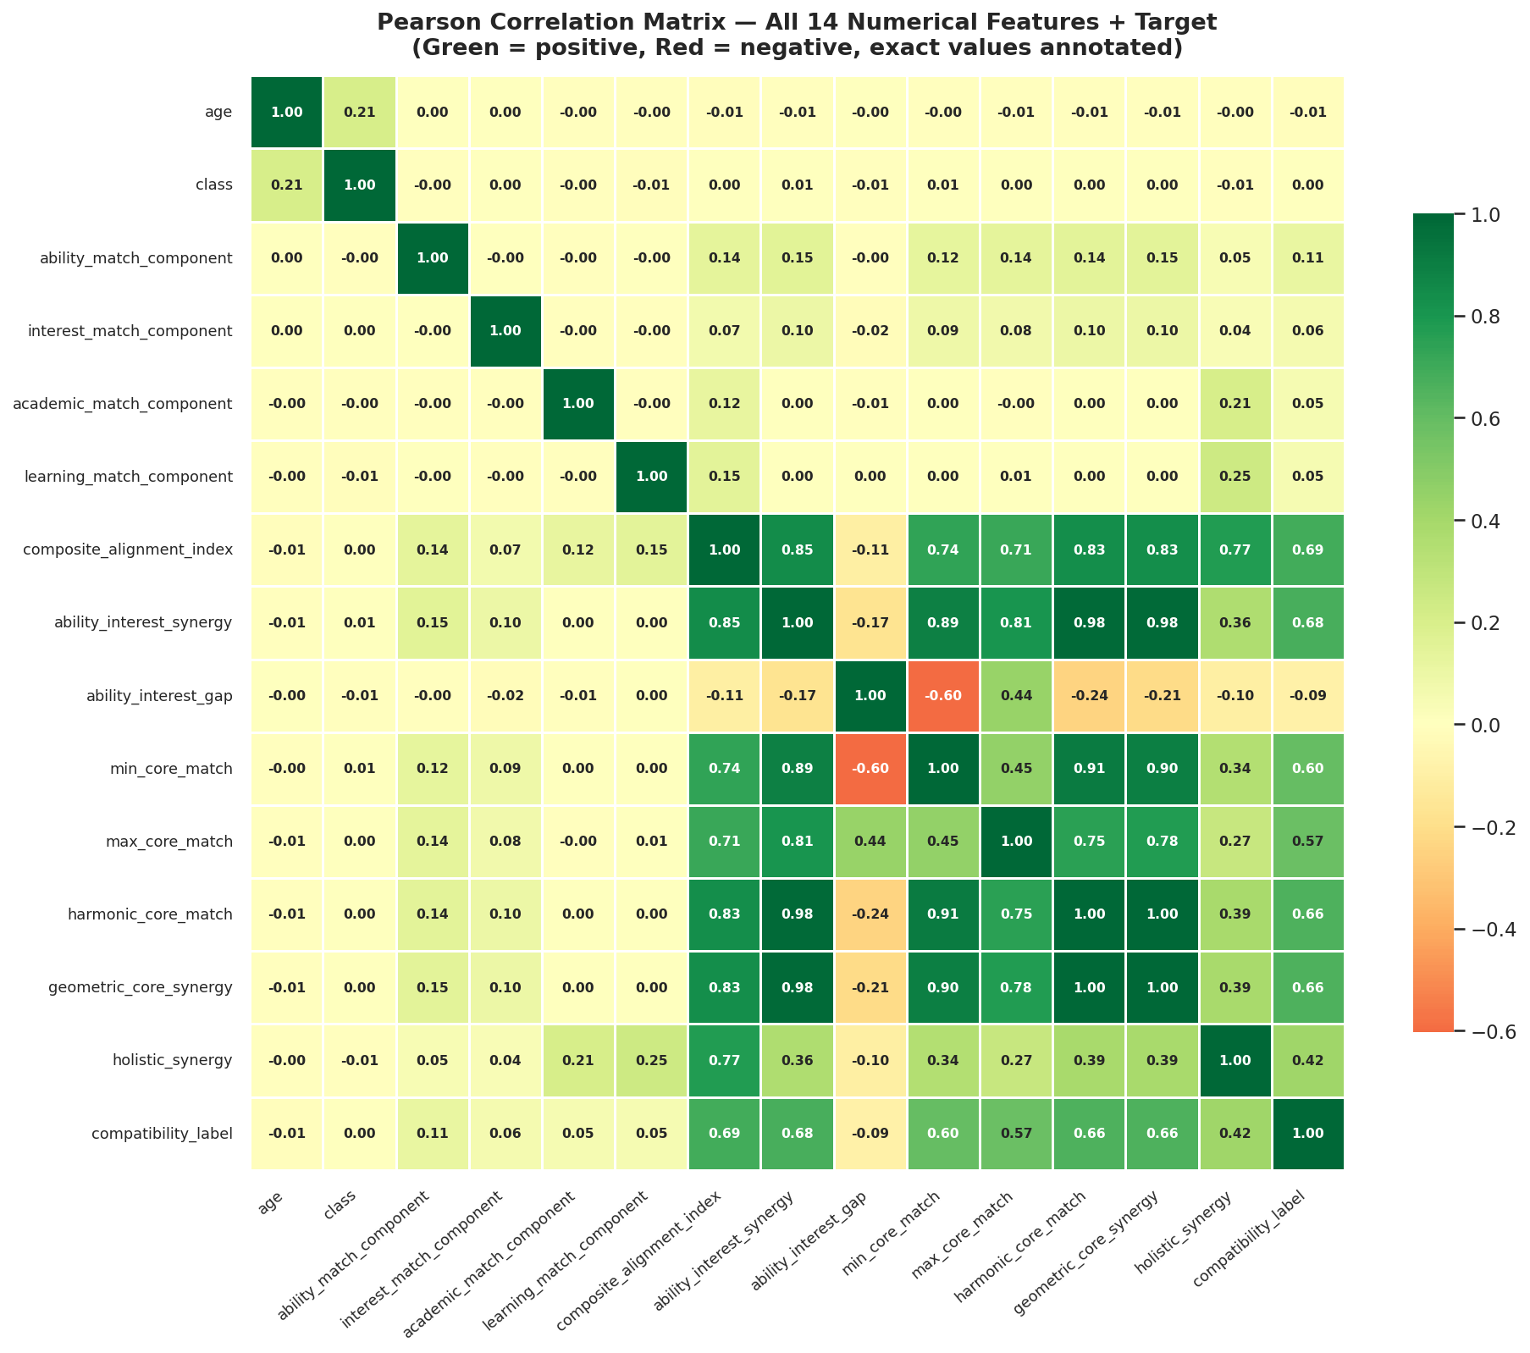
Fig. 3.22: Correlation Analysis Heatmap
Correlation analysis is used as an exploratory technique rather than the sole method for selecting features. The final feature set also considers the structure of the dataset, the meaning of each attribute, and the requirements of the machine learning pipeline.
B) Pre-processed Dataset
a. Shape and Information
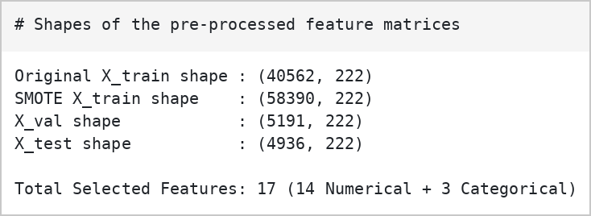
Fig. 3.23 Shape and Description of the Pre-processed Dataset
The shape and information of the dataset provide an overview of the number of records, columns, data types, non-missing values, and memory usage. These details help understand the structure of the dataset before applying machine learning algorithms.
The original student–career dataset contains 50,689 records and 22 columns. Each record represents a student–career combination. The dataset contains student characteristics, career-related information, matching components, and the compatibility label.
The important features include:
- Student-related features: age and class, which represent the student's age and educational level.
- Career-related features: stream, career_domain, career_subdomain, career_cluster, and career_name, which describe the educational and career categories.
- Matching features: ability_match_component, interest_match_component, academic_match_component, and learning_match_component, which represent different dimensions of student–career matching.
- Alignment features: composite_alignment_index, ability_interest_synergy, ability_interest_gap, and other alignment measures that describe relationships between matching components.
- Target variable: compatibility_label, which indicates whether a career is compatible or incompatible with a student's profile.
During preprocessing, the selected numerical and categorical features are handled using appropriate imputation, scaling, and encoding techniques. Identifier columns such as student_id and career_id are excluded from the model input.
b. First Five Records of the Dataset
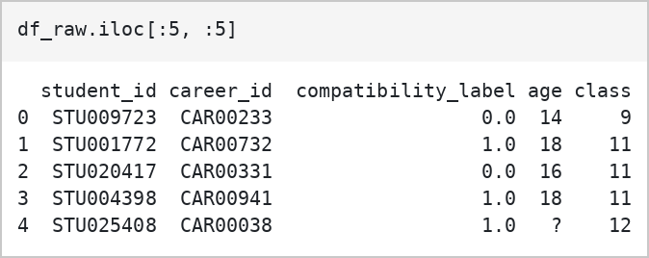
Fig. 3.24 First Five Records of the Pre-processed Dataset
The first five records are displayed using the head() function. This helps examine the initial entries and understand how student information, career attributes, and compatibility labels are represented in the dataset.
c. Statistical Summary
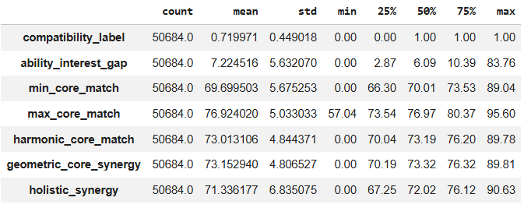
Fig. 3.25 Statistical Summary of the Pre-processed Dataset
The statistical summary is generated using the describe() function. It provides information such as count, mean, standard deviation, minimum, maximum, and quartiles for numerical features.
The summary helps understand the distribution of student characteristics and career-matching measurements. Features such as age, class, and the different matching components provide information about student profiles and their relationship with possible career options.
The target variable, compatibility_label, represents the compatibility of a student with a career. Its class distribution is examined separately to understand the proportion of compatible and incompatible records.
The statistical summary and related visualizations help identify missing values, unusual observations, and variations in the dataset before model training.
C) Dataset Split
The dataset is divided into training and testing subsets to evaluate how well the machine learning model predicts compatibility for unseen student–career records.
- Training Set: Used to train the model and learn patterns between the selected input features and compatibility labels.
- Testing Set: Kept separate from model training and used to evaluate the model's performance on unseen records.
Since a student may have multiple career records, the dataset is split at the student level using student_id. This prevents records belonging to the same student from appearing in both the training and testing sets, reducing the risk of data leakage. The split is 80% training, 10% validation and 10% testing: 40,562 training records (9,128 students), 5,191 validation records (1,141 students) and 4,936 test records (1,142 students), with zero student overlap between the sets.
The numerical and categorical features are processed using a preprocessing pipeline. Numerical features are handled using imputation and standardization, while categorical features are handled using imputation and one-hot encoding. The transformations are fitted on the training data and applied to the testing data.
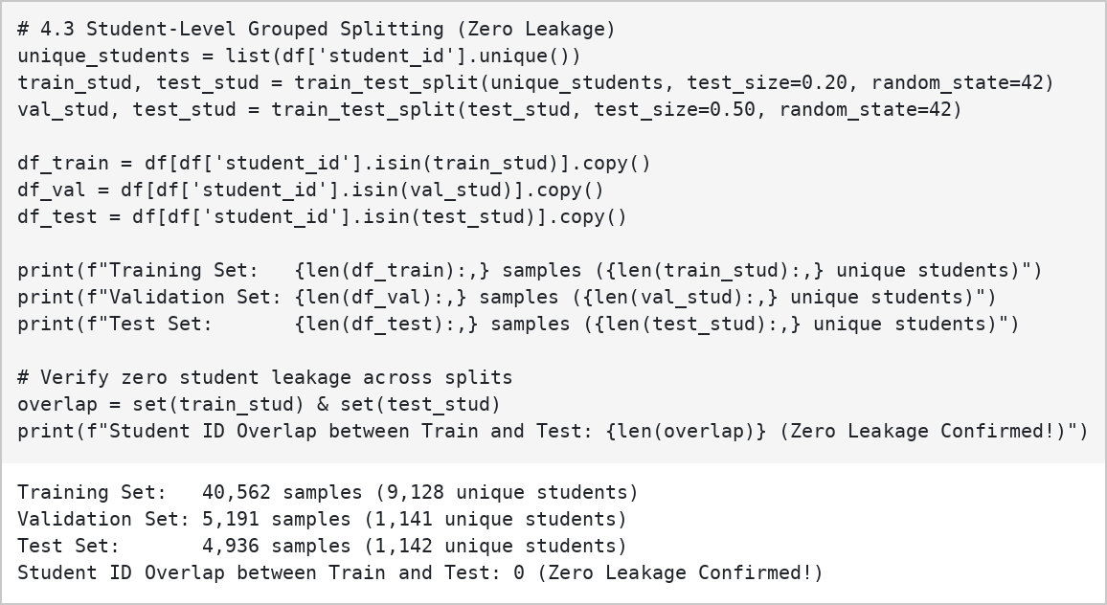
Fig. 3.26 Dataset Split

3.2.3 Analysis of Class Variables
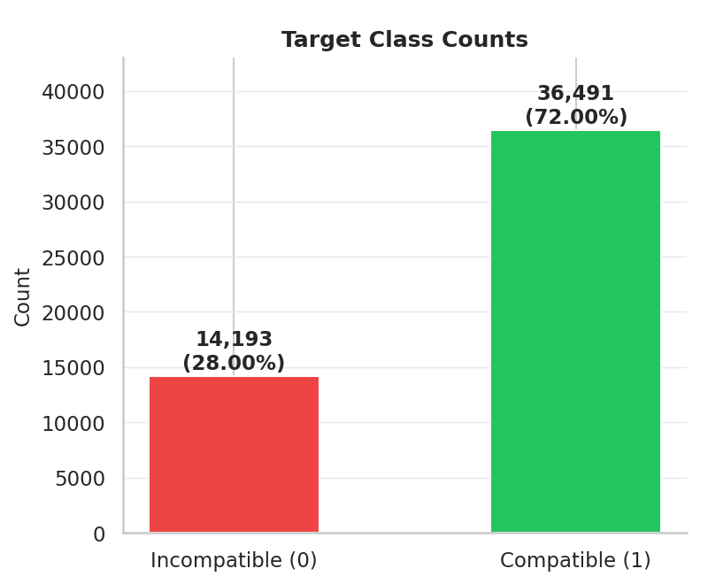
Fig. 3.27 Target Class Distribution
The target class distribution is visualized using a bar chart to examine the number of compatible and incompatible student–career records.
The target variable is compatibility_label, which contains two classes:
- 1 – Compatible: Indicates that the career is classified as compatible with the student's profile.
- 0 – Incompatible: Indicates that the career is classified as incompatible with the student's profile.
The class distribution shows that compatible records are more frequent than incompatible records. This indicates an imbalance in the target variable, which may influence the predictions made by a machine learning model.
To address class imbalance, SMOTE is applied only to the training data. The validation and testing data are kept unchanged so that model evaluation reflects the original distribution of the records.
Analyzing the target classes helps determine the need for balancing techniques and supports the development of a more reliable student–career compatibility prediction model.

3.3 Data Visualization
Data visualization is used to understand the characteristics and distribution of the student–career dataset. Different graphs are generated to examine student profiles, career categories, compatibility labels, and matching components. These visualizations help identify patterns and understand the relationships between the features before developing the machine learning models.
a) Compatibility Label Distribution
Fig. 3.28 Compatibility Label Distribution
The bar chart displays the distribution of the two classes in the compatibility_label variable. The classes represent compatible and incompatible student–career combinations. This visualization helps identify whether the dataset is balanced or imbalanced and indicates whether class-balancing techniques may be required during model training.
b) Age Distribution
Fig. 3.29 Age Distribution
The age distribution graph illustrates the spread of student ages in the dataset. It helps understand the age groups represented and identify unusual or missing values. Age is an important descriptive attribute because students at different educational stages may have different career interests and academic backgrounds.
c) Career Cluster Distribution
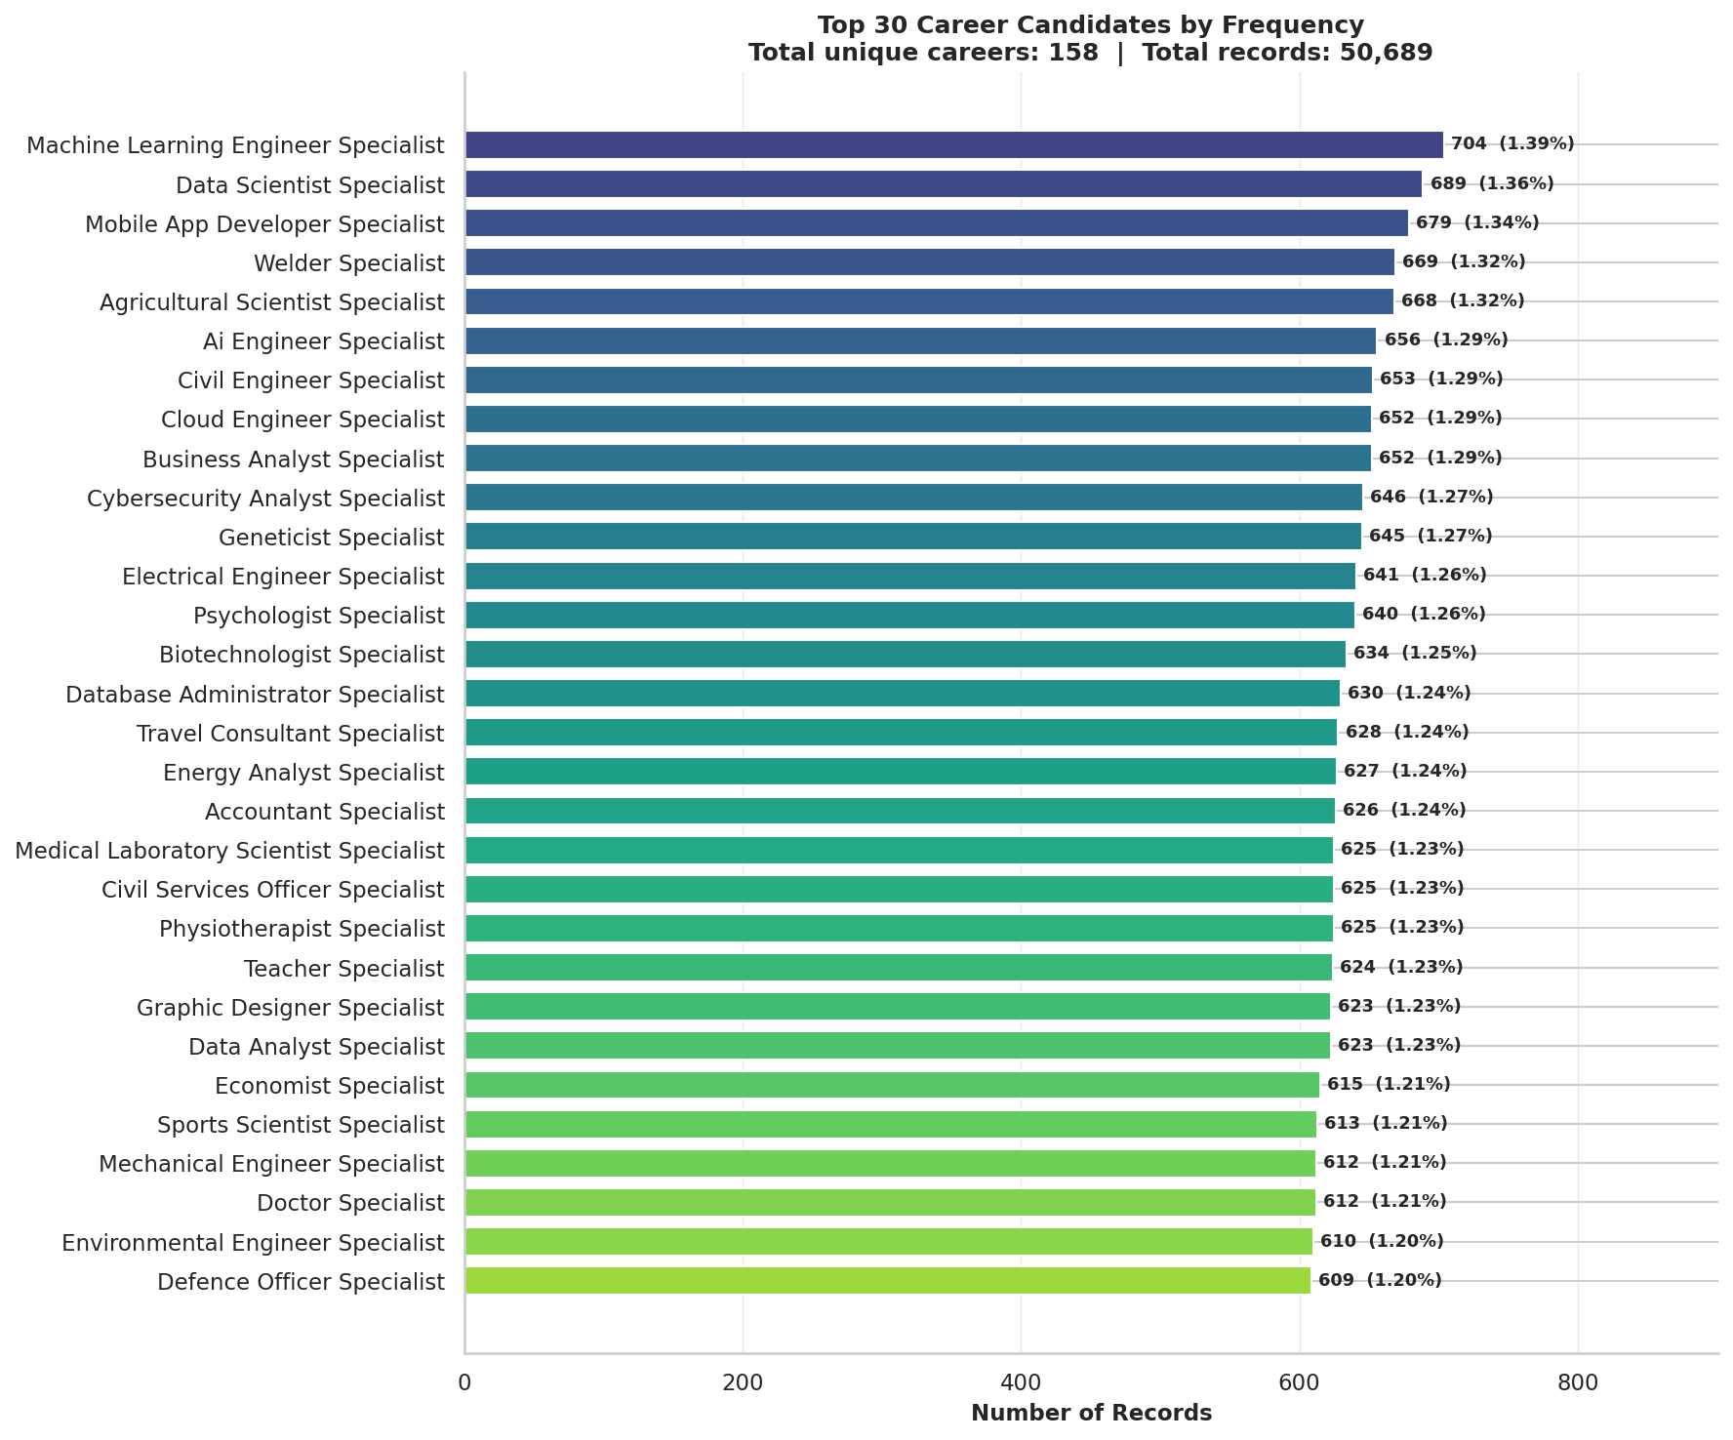
Fig. 3.30 Career Candidate Frequency (Top 30)
The chart shows the 30 most frequent career candidates among the 158 unique careers in the cleaned dataset (50,689 records in total). The career_cluster and career_subdomain columns contain only arbitrary placeholder labels (such as Cluster 1-30 and Track 1-8) with near-zero importance, so they are not used as model features.

d) Matching Components vs Compatibility Label
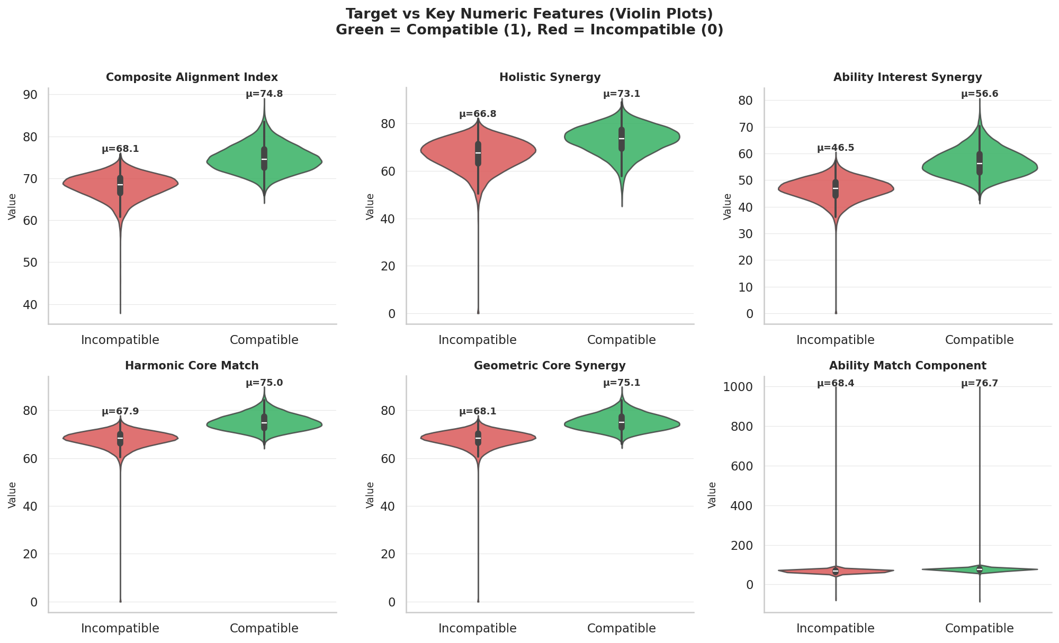
Fig. 3.31 Key Numerical Features vs Compatibility Label
Violin plots are used to compare the distributions of key numerical features, including composite_alignment_index, holistic_synergy, ability_interest_synergy, harmonic_core_match, geometric_core_synergy and ability_match_component, between the compatible and incompatible classes. They show that the alignment-based features separate the two classes much more clearly than the individual match components.
The comparison provides a descriptive view of how the matching components vary between the two classes. These features are also examined during feature analysis to understand their relationships with career compatibility. Since some matching components may be related to how the target label was constructed, they must be carefully assessed for potential target leakage before being used as model inputs.
3.4 Analysis of Architecture Algorithm
3.4.1 Proposed Algorithms
i) Random Forest (RF)
a. Description and Justification
Random Forest is an ensemble machine learning algorithm that combines multiple decision trees to perform classification. Each tree is trained using a sample of the training data and a randomly selected subset of features. The predictions from the trees are combined using majority voting to determine the final class.
Why chosen:
- Handles complex relationships: Random Forest can identify non-linear relationships between student characteristics and career compatibility.
- Reduces overfitting: Combining multiple decision trees helps reduce the risk of relying on the patterns learned by a single tree.
- Feature importance: It can provide feature importance scores to help understand which input features contribute to predictions.
- Suitable for classification: It can classify student–career combinations into compatible and incompatible categories.
b. Flowchart
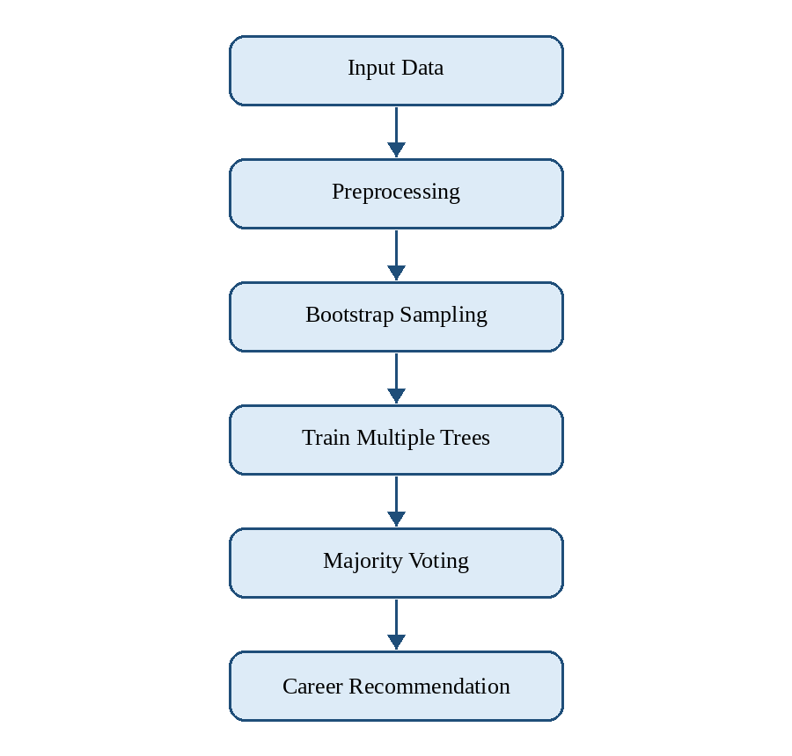
Fig. 3.32 Flowchart of Random Forest
c. Pseudocode
Input: Training dataset (X, Y)
Step 1: Prepare the training dataset and selected input features.
Step 2: For each tree in the forest:
- Select a random sample of training records.
- Select a random subset of features.
- Build a decision tree using the selected data and features.
Step 3: Repeat until the required number of trees is trained.
Step 4: For a new student–career record:
- Pass the input through all trained trees.
- Collect the predictions from each tree.
- Combine the predictions using majority voting.
Step 5: Produce the final classification: Compatible or Incompatible.
ii) XGBoost (Extreme Gradient Boosting)
a. Description and Justification
XGBoost is an ensemble machine learning algorithm based on gradient boosting. It builds decision trees sequentially, with each new tree helping to reduce the errors made by the existing model. The predictions from the trees are combined to produce the final classification.
Why chosen:
- High predictive capability: XGBoost can learn complex relationships between student profiles and career-related features.
- Suitable for structured data: It is designed to work effectively with tabular datasets containing numerical and categorical information after preprocessing.
- Regularization: It includes techniques that help control model complexity and reduce overfitting.
- Model comparison: It provides an additional approach for comparing predictive performance with Random Forest and LightGBM.

b. Flowchart
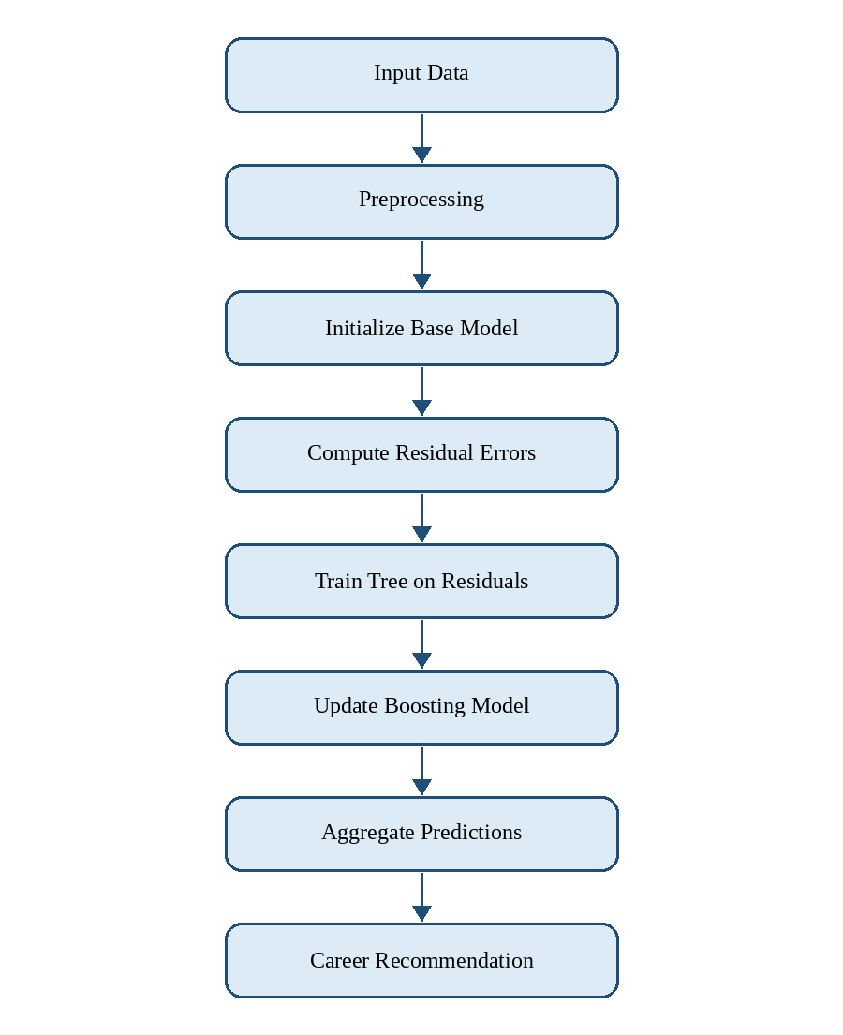
Fig. 3.33 Flowchart of XGBoost
c. Pseudocode
Input: Training dataset (X, Y)
Step 1: Initialize the model with an initial prediction.
Step 2: For each boosting round:
- Calculate the errors made by the current model.
- Train a decision tree to improve the existing predictions.
- Calculate the contribution of the new tree.
- Update the model by adding the new tree.
Step 3: Repeat the process for the specified number of boosting rounds.
Step 4: For a new student–career record:
- Obtain predictions from the trained ensemble.
- Combine the contributions of the trees.
- Calculate the predicted compatibility probability.
- Apply the classification threshold to determine the predicted class.
Step 5: Produce the final classification: Compatible or Incompatible.
iii) LightGBM (Light Gradient Boosting Machine)
a. Description and Justification
LightGBM is a gradient boosting algorithm that builds decision trees sequentially to improve prediction performance. It uses histogram-based techniques to process feature values efficiently and grows trees by selecting leaves that provide the greatest improvement to the objective function.
Why chosen:
- Computational efficiency: Histogram-based learning helps reduce training time and memory usage.
- Complex pattern learning: It can capture non-linear relationships between student characteristics and career attributes.
- Suitable for tabular data: It supports classification tasks involving structured datasets.
- Performance comparison: It allows the project to compare another boosting algorithm with Random Forest and XGBoost.
b. Flowchart
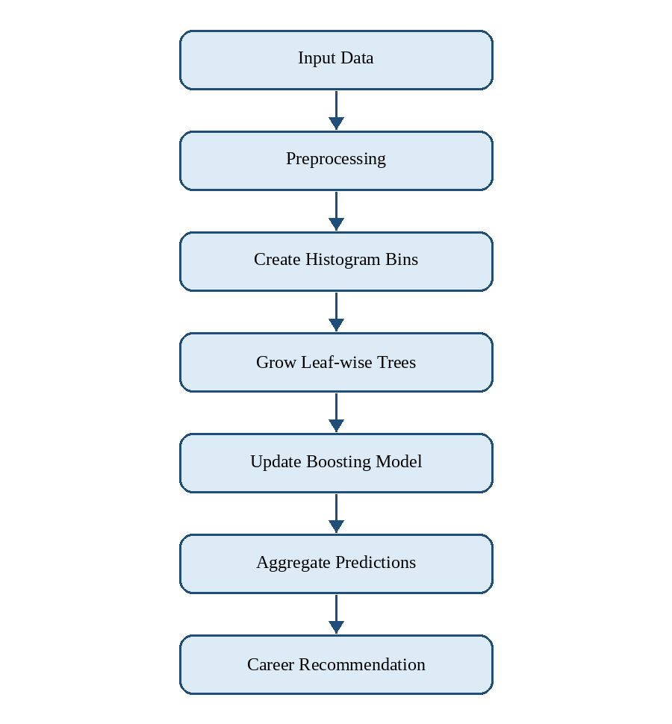
Fig. 3.34 Flowchart of LightGBM

c. Pseudocode
Input: Training dataset (X, Y)
Step 1: Initialize the model with an initial prediction.
Step 2: Convert feature values into histogram bins.
Step 3: For each boosting round:
- Calculate the gradients and errors.
- Identify the leaf that provides the best improvement.
- Split the selected leaf to create a new tree structure.
- Update the model using the new tree.
Step 4: Repeat until the specified number of boosting rounds is completed.
Step 5: For a new student–career record:
- Generate predictions using the trained ensemble.
- Calculate the compatibility probability.
- Apply the classification threshold.
Step 6: Produce the final classification: Compatible or Incompatible.
Objective of the Project
The objective of this project is to develop a personalized career recommendation system using machine learning. The system predicts whether a career is compatible with a student's profile using relevant student assessment features and career-related information.
The target variable, compatibility_label, represents two classes: Compatible (1) and Incompatible (0). The predicted compatibility probabilities can be used to rank suitable career options for a student.
The project compares Random Forest, XGBoost, and LightGBM to identify the most suitable model. The models are evaluated using metrics such as accuracy, precision, recall, F1-score, and ROC-AUC. The final model is the one achieving the highest accuracy on the held-out test data, supported by the F1-score and ROC-AUC because the target classes are imbalanced.
The selected model is then used to support personalized career recommendations by estimating the compatibility of different careers with a student's profile.
3.5 Project Pipeline
3.5.1 Project pipeline diagram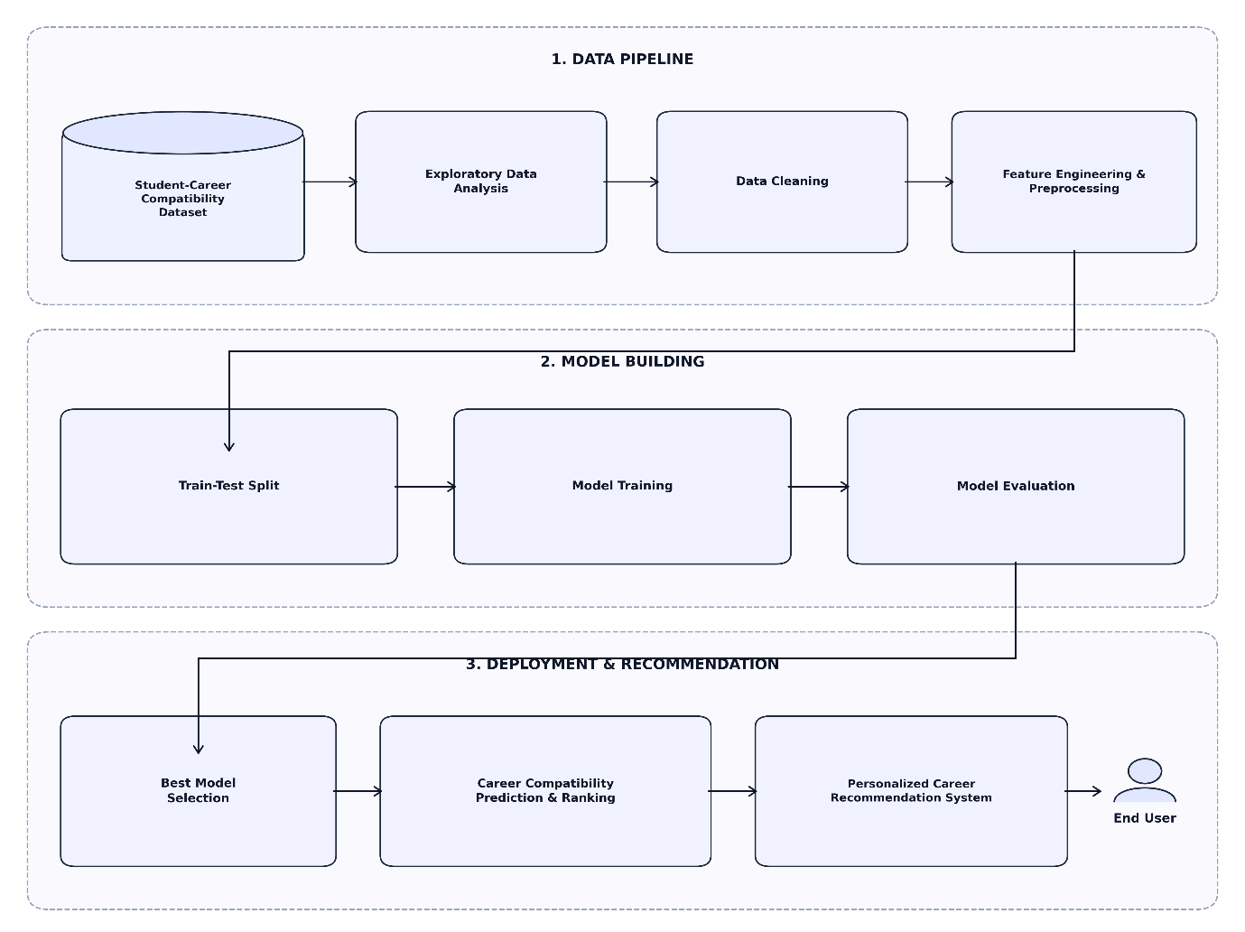
Fig. 3.35: Project Pipeline
• Data Preparation
The process begins with the Student Career Recommendation Dataset, which contains student-related information and career compatibility details. Exploratory Data Analysis (EDA) is performed to understand the dataset, examine the distribution of compatibility labels, analyze student characteristics, and explore career domains and clusters. Data preprocessing is then carried out to improve data quality and prepare the dataset for machine learning. This involves handling missing values, processing numerical and categorical attributes, and selecting relevant input features. Identifier columns such as student_id and career_id are excluded from model training, and the data is split at the student level to prevent leakage between the training, validation and test sets. The target variable, compatibility_label, represents whether a student is compatible or incompatible with a particular career.
• Model Building
After data preparation, the processed dataset is used to train and evaluate machine learning models for career compatibility prediction. The algorithms included in the project are selected according to the implemented notebook. Random Forest uses multiple decision trees to capture relationships between student characteristics and career compatibility. XGBoost applies gradient boosting to build an ensemble of decision trees, while LightGBM provides another gradient-boosting approach designed for efficient model training. The models are compared using suitable evaluation metrics, including accuracy, precision, recall, and F1-score, where implemented. The final model is selected based on the evaluation results, with the champion model selected on the highest test accuracy and supported by the F1-score and ROC-AUC.
• Deployment
After selecting the best-performing model, it can be integrated into the Personalized Career Recommendation System to support career guidance. The system can use relevant student information to predict compatibility with different career options. Based on the prediction results, careers can be ranked according to their predicted compatibility, helping students identify options that align with their profiles. The system aims to support informed career decisions by providing machine-learning-based recommendations. The deployment description should be updated to reflect the actual implementation of the web application and model integration.
3.6 Feasibility Analysis
A feasibility study evaluates the practicality and viability of a proposed system by analyzing the resources, constraints, and overall capability to develop and deploy the system successfully. For the Personalized Career Recommendation System Using Machine Learning, the feasibility has been evaluated under the following categories:
- Technical Feasibility
- Economic Feasibility
- Operational Feasibility
3.6.1 Technical Feasibility
The proposed system is developed using the Python ecosystem and widely used machine learning libraries such as Pandas, NumPy, Scikit-learn, XGBoost, LightGBM, Matplotlib, Seaborn, and Flask. Student data is stored in CSV format and preprocessed efficiently before training the machine learning models. The use of open-source tools and standard development technologies ensures that the system can be implemented, tested, and deployed with minimal technical complexity.
3.6.2 Economic Feasibility
The project requires minimal financial investment as all development tools and machine learning libraries, including Python, Flask, Pandas, NumPy, Scikit-learn, XGBoost, and LightGBM, are open-source and freely available. The system can be developed and deployed on a standard personal computer without requiring specialized hardware or licensed software, making it economically feasible.
3.6.3 Operational Feasibility
The proposed system provides a simple and user-friendly web interface through which students can enter their academic details, skills, interests, and aptitude assessment responses. The machine learning model analyzes the student profile and generates personalized career recommendations automatically. Since the system is easy to use and requires no technical expertise, it can be effectively adopted by students and educational institutions for career guidance.
3.7 System Environment
The system environment defines the software and hardware resources required for developing, training, testing, and executing the proposed Personalized Career Recommendation System. The system uses Python-based machine learning technologies for data preprocessing, model training, and career prediction. Google Colab and Visual Studio Code are used for model development and application implementation. The system uses machine learning algorithms to analyze student assessment and career-related data and recommend suitable career roles based on their skills, interests, and other relevant attributes. The required environment is designed to support efficient development and execution without the need for specialized hardware.

3.7.1 Software Environment

The software tools and technologies used for developing the proposed Personalized Career Recommendation System are presented in Table 3.7.1.

Software | Specification
Operating System | Windows 11
Frontend Technologies | HTML, CSS, JavaScript
Programming Language | Python
Web Framework | Flask
Database Management System | MySQL
Machine Learning Libraries | Scikit-learn, XGBoost
Data Processing Libraries | Pandas, NumPy
IDE | Visual Studio Code
Notebook Environment | Google Colab
Version Control | Git and GitHub
Table 3.7.1 Software Environment

3.7.2 Hardware Environment

The proposed system can be developed and executed using a standard personal computer without requiring specialized hardware. The minimum hardware requirements considered for the development and execution of the system are presented in Table 3.7.2.

Hardware | Specification
Processor | Intel Core i5 or equivalent
RAM | 8 GB or higher
Storage | 256 GB SSD or higher
Table 3.7.2 Hardware Environment
3.8 Actors and Roles
The proposed Student Career Recommendation System consists of two primary actors, the Student and the Admin, who interact with the system to perform different functions. The Student provides personal, academic, and assessment-related information and obtains suitable career recommendations. The Admin manages the question bank, student performance reports, and machine learning model used by the system.
3.8.1 User (Student)
The Student is the primary user of the proposed system. As a registered user, the Student can log in to the system, register and manage their profile, take the adaptive career assessment, submit assessment responses, and obtain personalized career recommendations based on the assessment results. The Student can also log out of the system.
Responsibilities
· Log in securely to the system.
· Register and manage personal and academic profile information.
· Take the adaptive career assessment.
· View personalized career recommendations.
· View assessment results and recommendation details.
· Log out of the system.
3.8.2 User (Admin)
The Admin is responsible for managing and maintaining the major components of the proposed system. The Admin can log in to the system and manage the question bank. The Admin can also view student performance reports and manage the machine learning model by training and evaluating it to support accurate career recommendations.
Responsibilities
· Log in securely to the system.
· Manage the question bank used for student assessments.
· View student performance reports.
· Train and evaluate the machine learning model.
· Maintain the assessment and career recommendation components of the system.

4. System Design
4.1 Models Building
The model building phase of the Personalized Career Recommendation System Using Machine Learning establishes a systematic approach for developing and evaluating machine learning models that can identify whether a particular career is compatible with a student's profile. The model development process uses relevant student, academic, interest, ability, and career-related attributes to learn patterns from the prepared dataset and generate career compatibility predictions.
1. Objective
The main objective is to develop a machine learning system that predicts career compatibility based on the characteristics of a student and the selected career. The prediction is performed using relevant academic, interest, ability, learning, and career-related attributes.
The target variable, compatibility_label, represents whether the given student-career combination is compatible. The trained model is intended to support personalized career recommendations by identifying career options that have a higher level of compatibility with an individual student's profile.
2. Approach
Three supervised machine learning algorithms are implemented and compared:
- Random Forest: Selected for its ability to handle complex relationships between features and its ensemble-based approach, which helps reduce overfitting.
- XGBoost: Selected for its strong performance on structured datasets and ability to learn complex patterns through gradient boosting.
- LightGBM: Selected for its efficient training and ability to handle datasets with a large number of records and features.
The models are compared using evaluation metrics such as Accuracy, Precision, Recall, and F1-score.

3. Data Preparation
The dataset contains 50,689 records and 22 columns, including student information, career information, matching components, and the compatibility_label target variable. The student_id is used for student-level grouping and is not used as a prediction feature.
The main data preparation steps include:
- Loading and examining the dataset.
- Handling missing values.
- Separating input features and the target variable.
- Processing numerical and categorical features.
- Removing irrelevant identifiers and features.
- Addressing class imbalance using the selected balancing technique.
- Preparing the processed data for model training and evaluation.
4. Exploratory Data Analysis (EDA)
EDA is performed to understand the structure and characteristics of the dataset before model training. The analysis includes:
- Examining the dataset shape, columns, and data types.
- Generating descriptive statistics for numerical features.
- Analyzing missing values.
- Studying the distribution of the compatibility_label.
- Visualizing important feature distributions.
- Examining relationships between relevant features.
These findings help in selecting appropriate features and preprocessing techniques for model development.
5. Model Training
The preprocessed dataset is divided into training, validation, and testing subsets. The Random Forest, XGBoost, and LightGBM models are trained using the training data. The validation set is used during model development, while the test set is used to evaluate the models on unseen data.
The models are compared using Accuracy, Precision, Recall, and F1-score. The confusion matrix and other relevant evaluation measures are also analyzed. The selected model is then used to predict career compatibility for new student-career combinations.
This structured model-building process provides a systematic approach for developing a machine learning-based career recommendation system using student and career-related information.
4.1.1 Implementation Code
The implementation of the Personalized Career Recommendation System integrates three machine learning algorithms: Random Forest, XGBoost, and LightGBM. The implementation begins by importing the required libraries for data processing, model training, and performance evaluation.
The preprocessed dataset is loaded and the input features (X) and target variable (y) are separated. The models are then trained using the prepared training data. Random Forest uses an ensemble of decision trees, while XGBoost and LightGBM use gradient boosting techniques to learn patterns from the dataset.
After training, the models are used to generate predictions on the validation and testing data. Their performance is evaluated using metrics such as Accuracy, Precision, Recall, and F1-score. Confusion matrices and other visualizations are also used to analyze model performance.
The implementation therefore provides a complete machine learning workflow, starting from the prepared dataset and model training to prediction and performance evaluation.
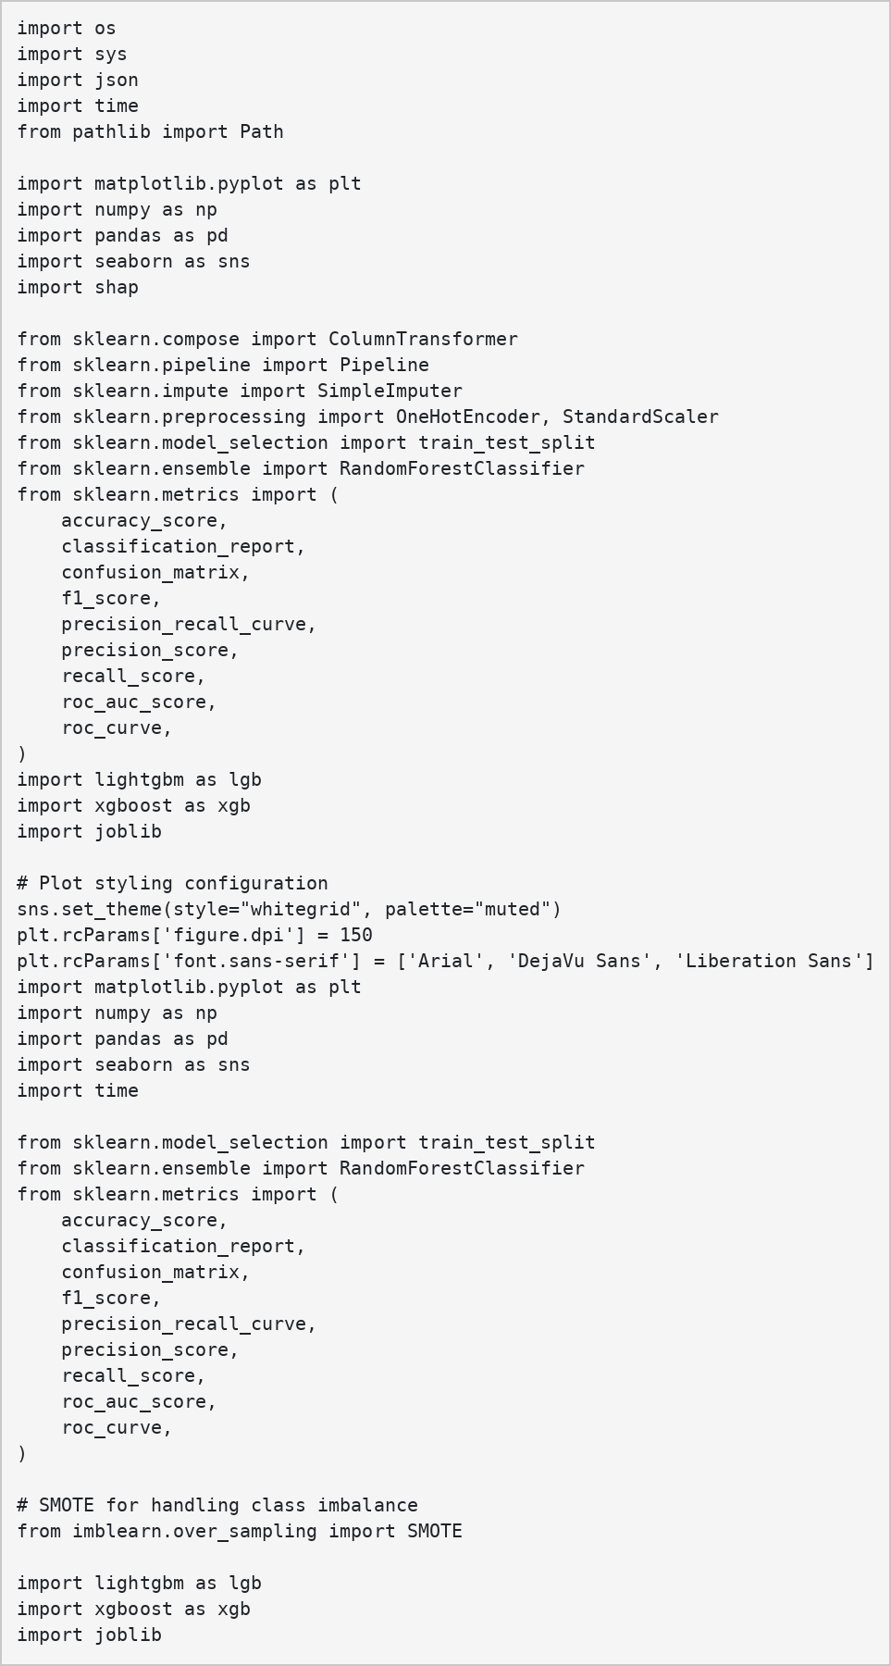
Fig 4.1 Importing libraries
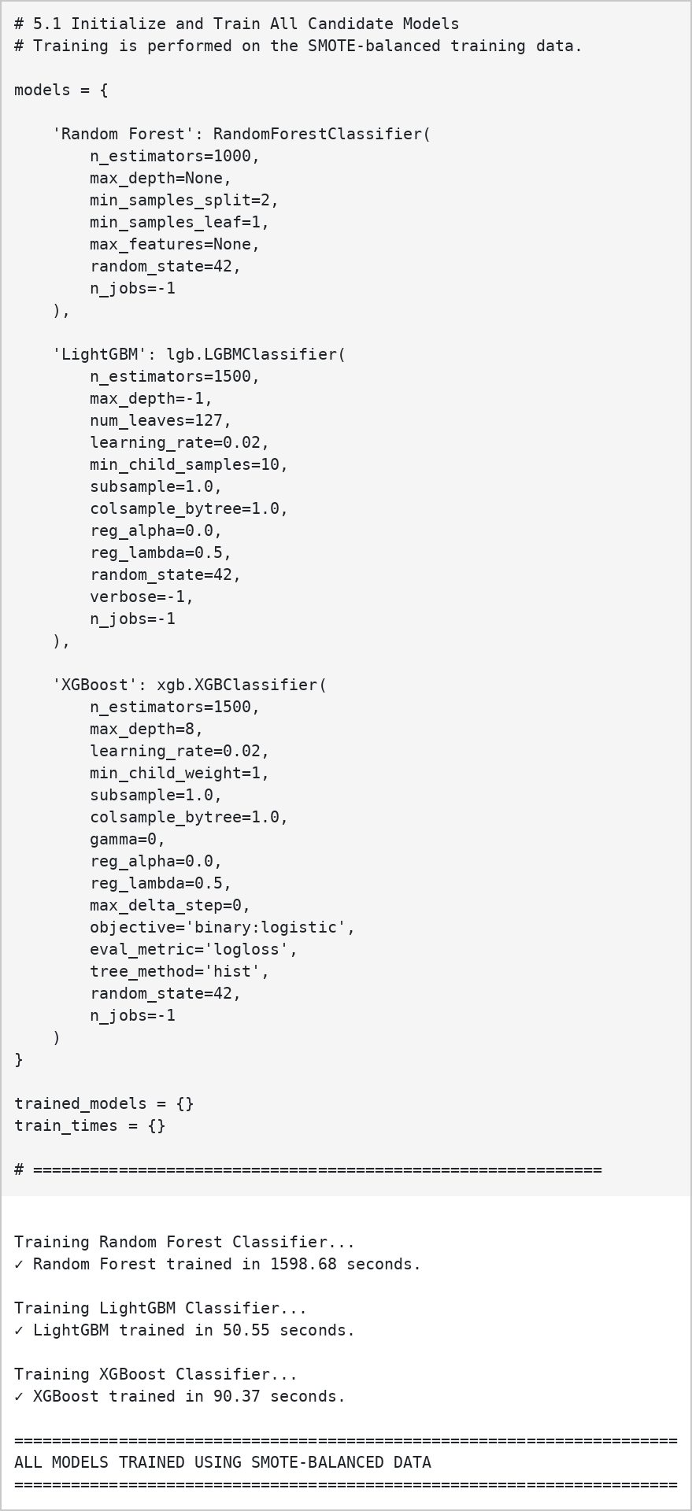
Fig 4.2 Implementing algorithms
4.1.2 Model Planning
To ensure reliable model performance, the dataset was divided into training, validation, and testing subsets using a 80:10:10 ratio (80% training, 10% validation, 10% testing). This allows the models to learn from the training data, be assessed during development using the validation data, and finally be evaluated on unseen testing data.
The dataset was prepared after completing the required preprocessing steps, including handling missing values, processing categorical and numerical features, and addressing class imbalance. The student-level grouping was also considered during dataset splitting to avoid unnecessary overlap between data used for model development and evaluation.
Random Forest, XGBoost, and LightGBM were selected because they are suitable for structured tabular data and can capture complex relationships between student and career-related features. The planned workflow includes training the three models, evaluating their performance on the validation and testing datasets, and comparing metrics such as Accuracy, Precision, Recall, and F1-score.
This model planning approach ensures that the developed models are properly trained and evaluated on unseen data before being used for career compatibility prediction.
Fig 4.3 Train-Test Split
4.1.3 Training
The training phase focuses on developing the machine learning models for predicting career compatibility. The preprocessed and balanced dataset is used to train the Random Forest, XGBoost, and LightGBM models. Relevant student and career-related features are provided as input to help the models learn the patterns associated with the compatibility_label.
Each model is trained using the training dataset. Random Forest learns through an ensemble of decision trees, while XGBoost and LightGBM use gradient boosting techniques to improve prediction performance by learning from previous errors.
During the training process, the models learn the relationship between the selected input features and the compatibility label. The validation data is used to assess model performance during development, while the separate testing data is reserved for final evaluation on unseen records.
The trained models are then evaluated using Accuracy, Precision, Recall, and F1-score. The results obtained from the different models are compared in the subsequent testing and results sections to determine their suitability for the career compatibility prediction task.
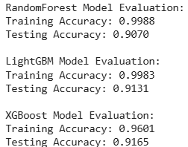
Fig 4.4 Trained Model Evaluation
4.1.4 Validation
The validation phase is used to assess the performance of the trained models during the model development process. The 10% validation dataset, which is separate from the training data, is used to evaluate the predictions generated by the Random Forest, XGBoost, and LightGBM models.
The validation results are analyzed using Accuracy, Precision, Recall, and F1-score to understand how well each model performs on data that was not used during training. The validation results also help in identifying possible overfitting and in comparing the models before the final evaluation.
Based on the validation performance, the models can be further refined and the suitable model can be selected for final testing. The 10% testing dataset is kept separate and is used only for the final evaluation of the selected model on unseen data.
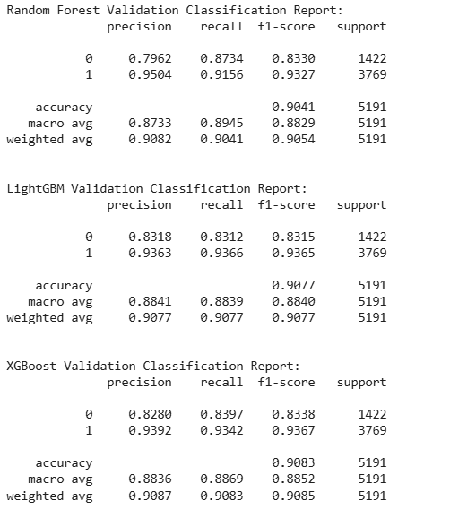
Fig 4.5 Validation Model Evaluation
4.1.5 Testing
The testing phase evaluates the performance of the developed career compatibility prediction models on unseen data. The 10% testing dataset, which is kept separate from the training and validation datasets, is used for the final evaluation of the models.
The performance of Random Forest, XGBoost, and LightGBM is evaluated using metrics such as Accuracy, Precision, Recall, and F1-score. These metrics help determine how effectively the models classify student-career combinations based on the compatibility_label.
The testing results provide an unbiased measure of the models' ability to generalize to unseen data. The results of the different models are compared, and the suitable model is considered for integration into the personalized career recommendation system.
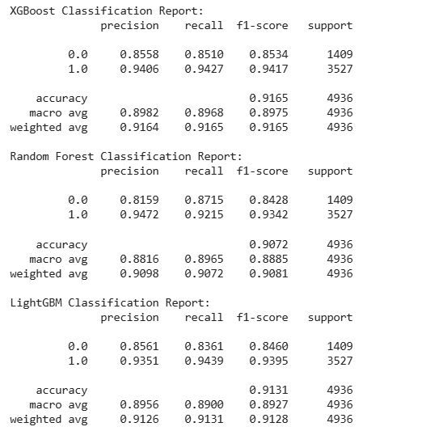
Fig 4.6 Testing classification reports

5. Results And Discussion
5.1 Model Performance Comparison
The performance of Random Forest, LightGBM, and XGBoost was evaluated using the unseen test dataset containing 4,936 samples. The models were compared using Accuracy, Precision, Recall, F1-Score, and ROC-AUC.
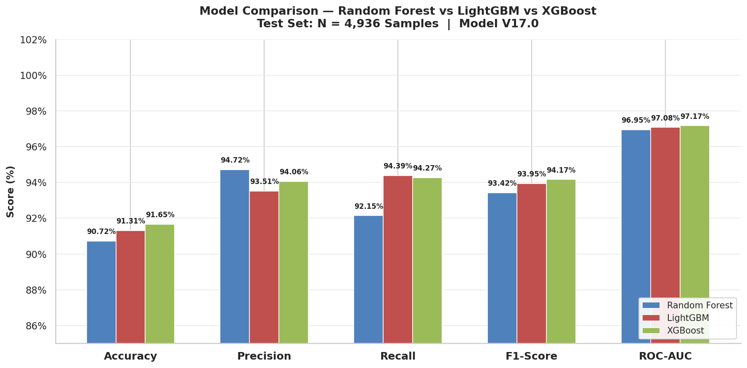
Fig 5.1: Model Performance Comparison
The results show that all three models achieved good classification performance on the unseen test set. XGBoost achieved the highest accuracy (91.65%), F1-score (94.17%) and ROC-AUC (97.17%), and was therefore selected as the champion model based on the highest test accuracy. Random Forest achieved the highest precision (94.72%) and LightGBM the highest recall (94.39%). The test accuracies of Random Forest and LightGBM were 90.72% and 91.31% respectively.
5.2 ROC Curve
The ROC curve is used to evaluate the ability of the models to distinguish between Compatible (1) and Incompatible (0) career combinations.
The ROC-AUC values obtained were 96.95% for Random Forest, 97.08% for LightGBM, and 97.17% for XGBoost. The high ROC-AUC values indicate that all three models have a strong ability to distinguish between the two compatibility classes.
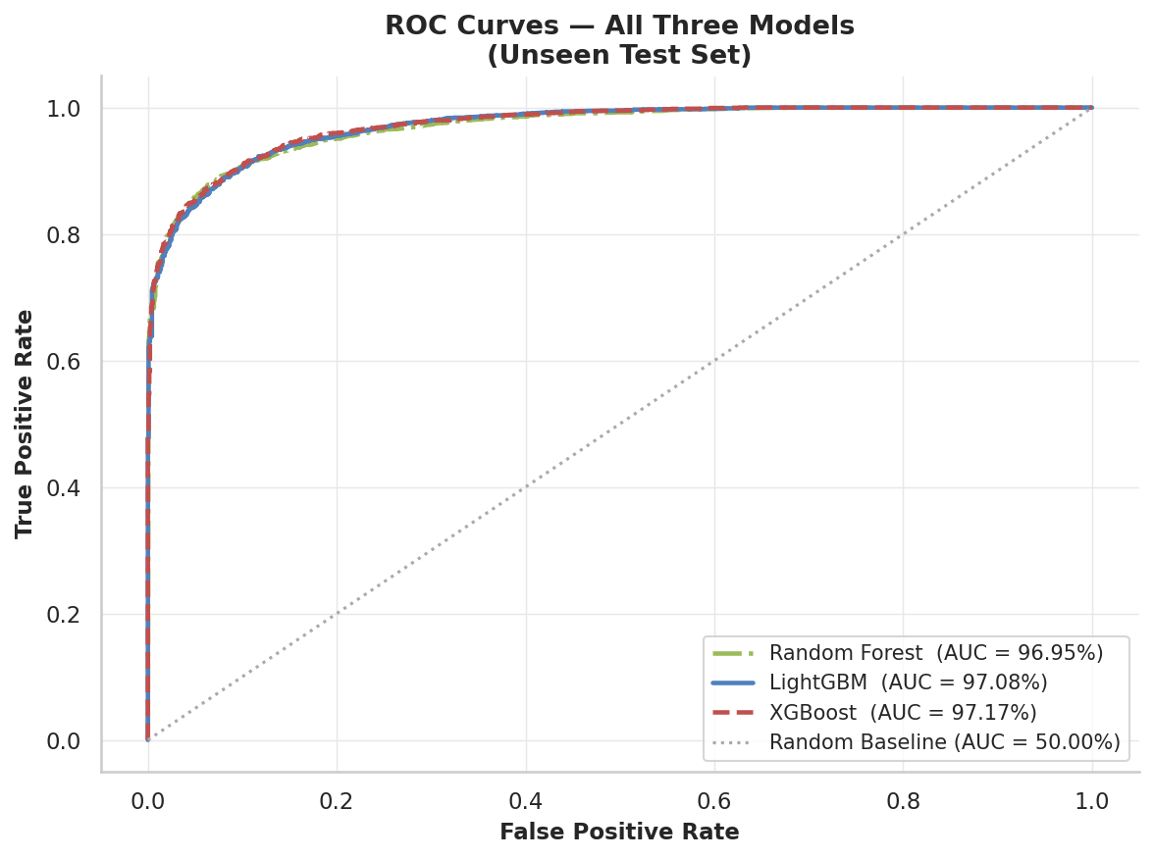
Fig 5.2: ROC Curves of the Three Models
5.3 Confusion Matrix
The confusion matrix shows the correctly and incorrectly classified instances for the two classes: Incompatible (0) and Compatible (1).
For the selected XGBoost model, 1,199 incompatible cases were correctly classified as incompatible, while 3,325 compatible cases were correctly classified as compatible. The model incorrectly classified 210 incompatible cases as compatible and 202 compatible cases as incompatible.
Overall, the model correctly classified 4,524 out of 4,936 test cases, resulting in a testing accuracy of approximately 91.65%. The confusion matrix provides a detailed view of the model's classification performance and the types of errors made during prediction.
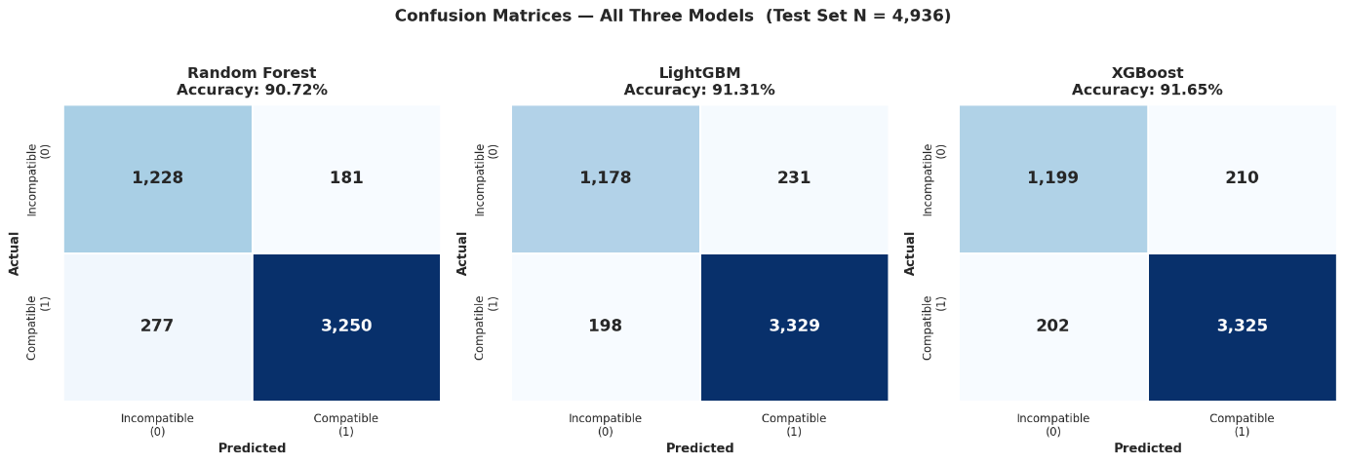

Fig 5.3: Confusion Matrix – Testing Data
5.4 Feature Importance
Feature importance analysis was performed using the selected XGBoost model to identify the features that contributed most to career compatibility prediction.
The most important features of the XGBoost model are composite_alignment_index (0.1556), geometric_core_synergy (0.1031), ability_interest_synergy (0.0323), harmonic_core_match (0.0186), age (0.0177) and class (0.0089), followed by one-hot encoded career_name and career_domain indicators.
Among these, composite_alignment_index had the highest importance, followed by geometric_core_synergy and ability_interest_synergy. This indicates that the overall alignment between the student and the career, together with the combined ability-interest synergy, are the main factors in the model's predictions.
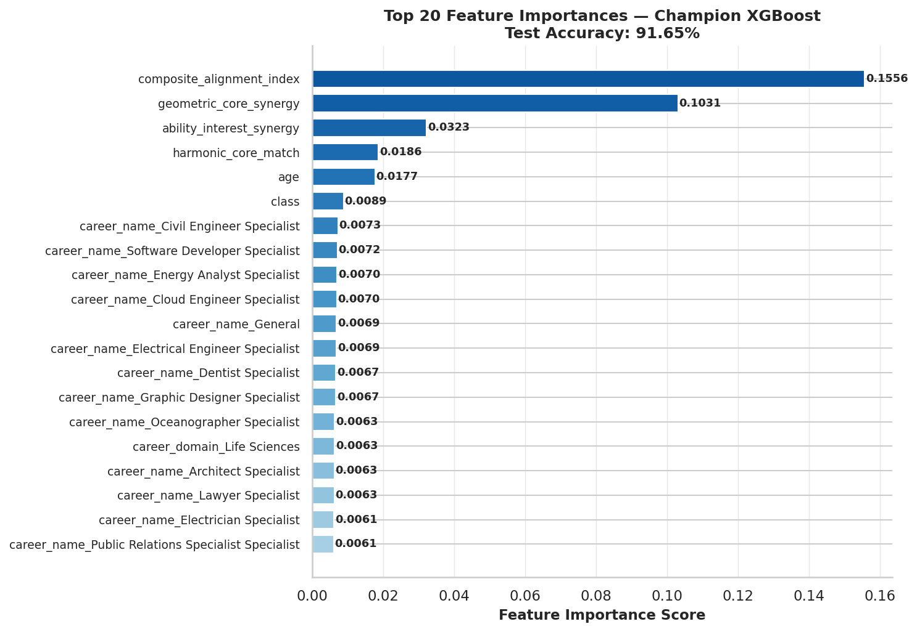
Fig 5.4: Top 20 Feature Importances of XGBoost
5.5 Prediction on Unseen Student Profiles
The trained XGBoost model was used to generate career compatibility predictions for five new student profiles. Each student profile was tested with three different career options, resulting in a total of 15 unseen student-career combinations.
For each combination, the model generated a compatibility probability and classified the career as either Compatible or Incompatible. The careers were ranked according to their predicted compatibility probability.
The prediction results showed that Student A, Student B, and Student E received compatible predictions for all three of their selected career options. Student A was evaluated with AI Engineer, Doctor, and Economist, while Student B was evaluated with Animator, Fashion Designer, and Civil Engineer. Student E was evaluated with Sports Coach, Content Creator, and Sports Scientist.
For Student C and Student D, all three tested career options were predicted as incompatible. Overall, out of the 15 unseen predictions, 9 were classified as Compatible and 6 as Incompatible, representing 60% and 40%, respectively. The average compatibility probability across all predictions was 59.66%.
These results demonstrate that the trained XGBoost model can be applied to new student profiles to evaluate career compatibility and support personalized career recommendations.
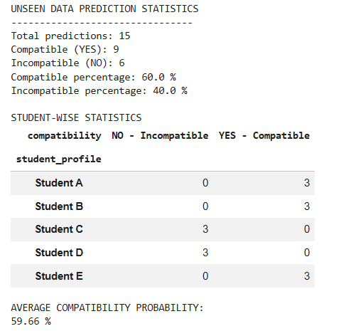
Fig 5.5: Career Prediction for Sample Student Profiles
The distribution of the 15 unseen predictions is shown in Fig 5.6.
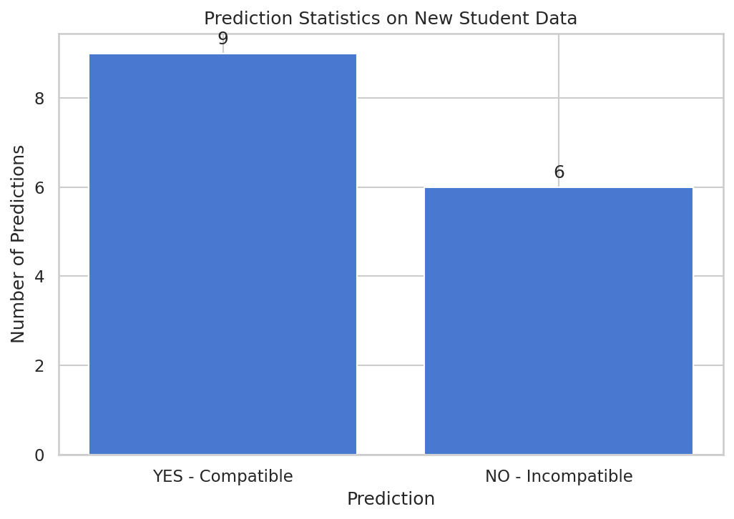
Fig 5.6: Prediction Statistics on New Student Data
5.6 Findings and Conclusions
The experimental results demonstrate that machine learning can be effectively used to predict career compatibility based on student and career-related attributes. Three models, Random Forest, LightGBM, and XGBoost, were trained and compared. Among the three models, XGBoost achieved the highest test accuracy of 91.65%, with an F1-score of 94.17% and ROC-AUC of 97.17%. Therefore, XGBoost was selected as the champion model for the proposed system.
The feature importance and SHAP analysis provided better understanding of the model's predictions. Features related to learning compatibility, academic compatibility, ability, interest, and overall alignment contributed significantly to the prediction process. This shows that career recommendation can be based on multiple aspects of a student's profile rather than relying only on academic performance.
The model was also tested on 15 unseen student-career combinations, where 9 were classified as Compatible and 6 as Incompatible. This demonstrates the ability of the trained model to evaluate new student profiles and generate career compatibility predictions.
Overall, the findings indicate that the proposed Personalized Career Recommendation System can use machine learning to analyze student characteristics and career-related information and provide personalized career compatibility predictions. The results show that the developed model provides a useful foundation for supporting students in exploring career options based on their individual profiles.

6. Model Deployment
The model deployment phase prepares the trained machine learning model for integration into the Personalized Career Recommendation System. The selected XGBoost model is saved along with its preprocessing pipeline so that new student profiles can be processed and evaluated using the same approach followed during model training.
The trained champion model and preprocessing pipeline are serialized using the Joblib library. The model is saved as model.joblib, and the preprocessing pipeline is saved as preprocessor.joblib. Both files are exported to the backend/ml/models/ directory for integration with the application.
When a new student profile and candidate career information are provided, the input data is processed using the saved preprocessing pipeline. The processed features are then passed to the trained XGBoost model to predict career compatibility and generate compatibility probabilities. The candidate careers can be ranked according to their predicted compatibility scores to identify suitable career options for the student.
The notebook also demonstrates this prediction process using five sample student profiles and different candidate careers. This approach prepares the trained model for application integration and supports personalized career compatibility prediction based on student characteristics and career-related attributes.

UI Design
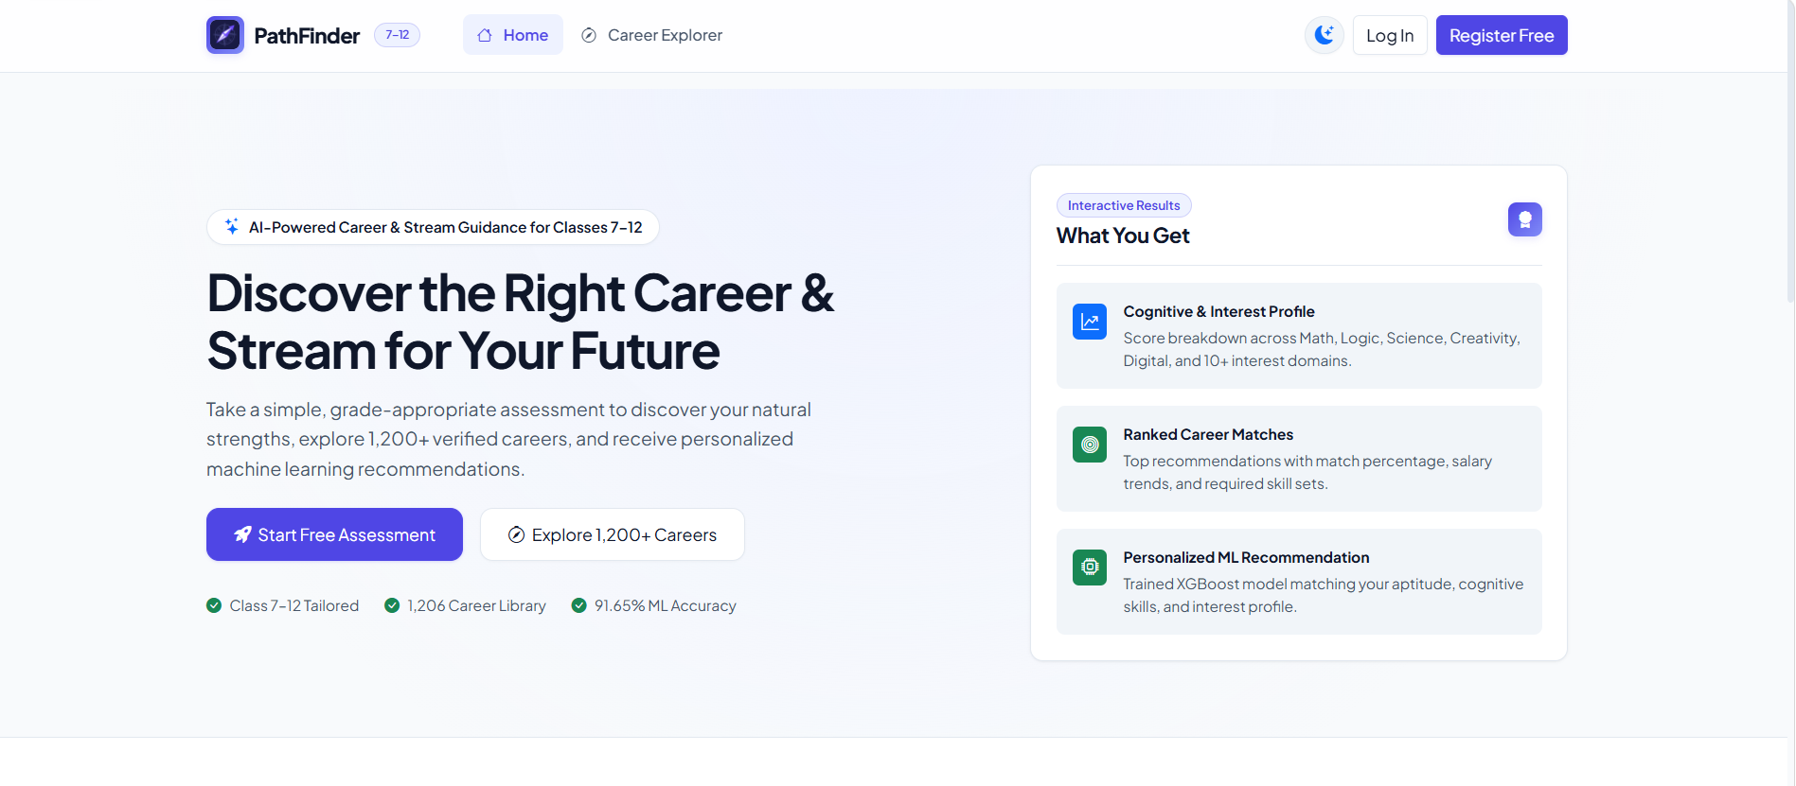
Fig 6.1 Welcome Page
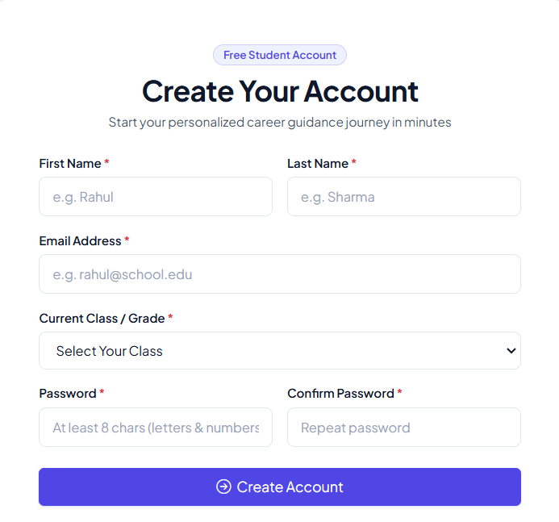
Fig 6.2 Input Page
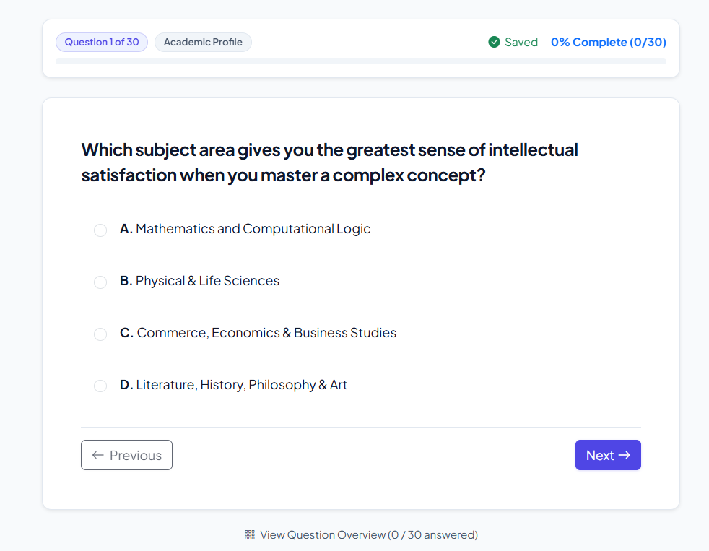
Fig 6.3 Assessment Page

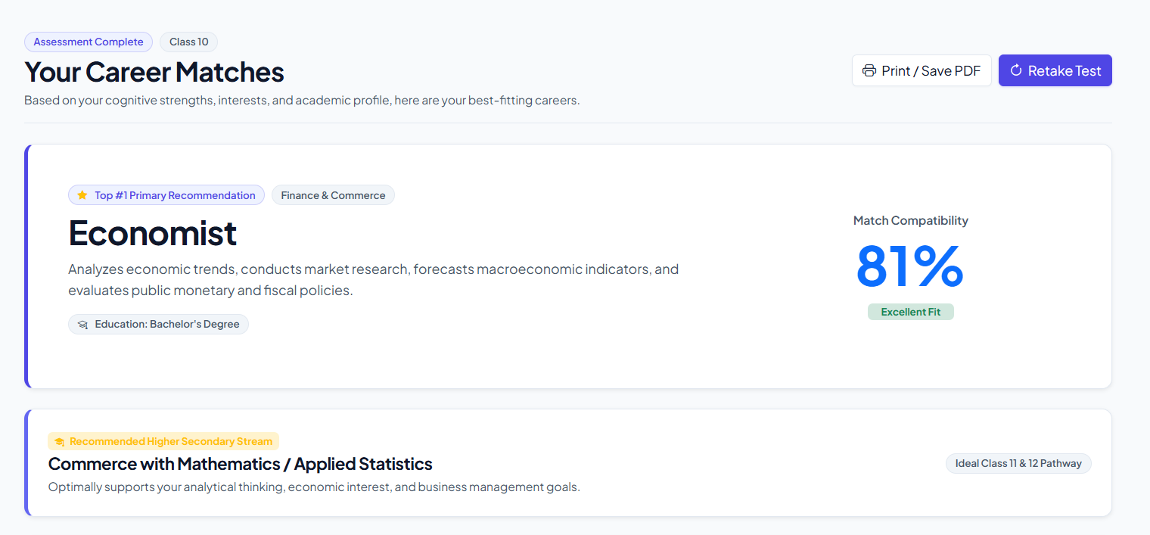
Fig 6.4 Result Page

7. Git History
The Git repository for the Personalized Career Recommendation System Using Machine Learning is used to maintain and manage the project files and track development changes. The repository can contain the machine learning implementation, data preprocessing scripts, model training code, evaluation outputs, and the application files used for career compatibility prediction.
The project uses Git for version control, allowing changes to be recorded and earlier versions to be reviewed when required. The trained XGBoost model and its preprocessing pipeline are exported for integration with the application. Maintaining the project files in a structured repository supports easier debugging, code maintenance, and future development.
The Git history provides a record of the development process and helps track modifications made to different components of the system. It also supports collaboration and provides a reference for future improvements, such as updating the dataset, refining the model, or adding new career recommendation features.
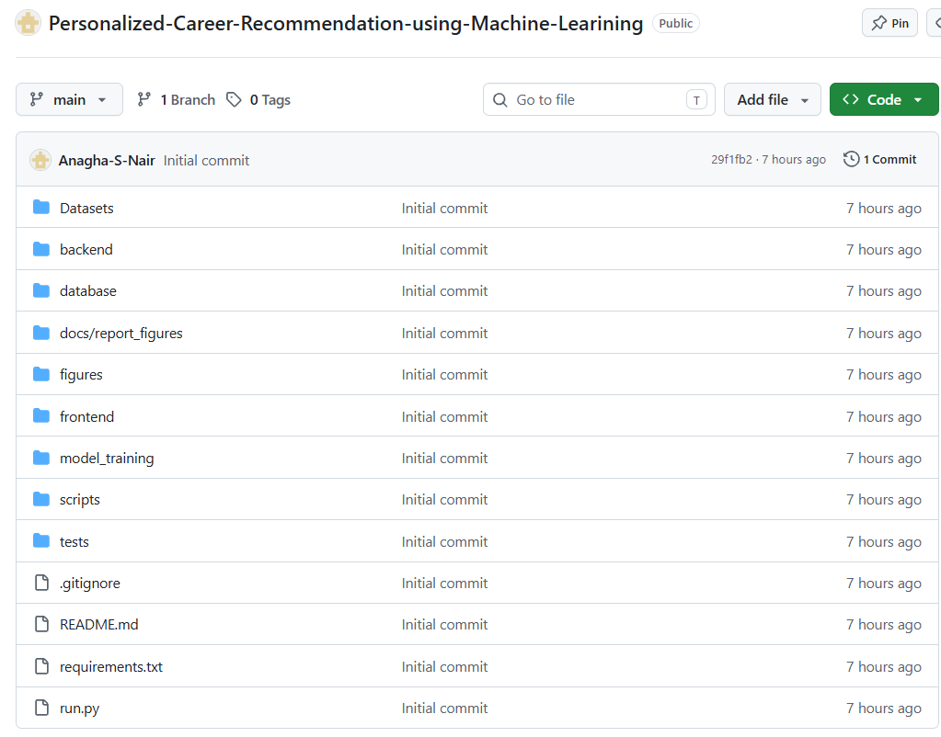
Fig 7.1. Git repository
8. Conclusion
The Personalized Career Recommendation System Using Machine Learning aims to help students identify suitable career options based on their academic performance, skills, interests, abilities, and other relevant characteristics. The system uses machine learning techniques to predict career compatibility and provide personalized recommendations that support students in making informed career decisions.
The project uses data preprocessing, exploratory data analysis, feature selection, and model training to develop a reliable career compatibility prediction system. Different machine learning algorithms were compared, and XGBoost was selected as the best-performing model, achieving a test accuracy of 91.65%, an F1-score of 94.17%, and a ROC-AUC score of 97.17%. These results demonstrate the model's ability to distinguish between compatible and incompatible career options in the test dataset.
The system combines machine learning with web technologies to provide a practical approach to career guidance. By evaluating student profiles against career-related information, it can help students explore suitable career paths according to their individual characteristics.
Overall, the project demonstrates the potential of machine learning in personalized career guidance. It provides a foundation for developing an intelligent career recommendation system that can assist students in exploring career opportunities and making better-informed educational and professional decisions.

9. Future Scope
- Advanced Machine Learning Algorithms: Future versions can explore additional machine learning algorithms and optimize existing models to improve career compatibility prediction. Algorithms such as CatBoost and other boosting techniques can be evaluated to identify opportunities for better performance.
- Additional Student Features: The system can be enhanced by including more student attributes, such as communication skills, extracurricular activities, problem-solving abilities, personal strengths, and learning preferences. These features may help generate more personalized career recommendations.
- Expanded Career Options: The system can be extended to include a wider range of careers from fields such as science, commerce, arts, healthcare, agriculture, engineering, and vocational education. This would allow students from different academic backgrounds to explore suitable career paths.
- Course and Education Recommendations: Future versions can recommend suitable educational streams, degree programs, certifications, and training courses based on students' academic performance, skills, interests, and career goals. This can help students plan their education after Class 10 and beyond.
- Explainability and Model Interpretation: Explainability techniques such as SHAP (SHapley Additive exPlanations) can be used to identify the student features that influence career compatibility predictions. This would help students understand the reasons behind recommendations and make informed decisions.
- Scalable Cloud Deployment: The application can be deployed on cloud platforms such as AWS, Microsoft Azure, or Google Cloud to support a larger number of users. Cloud deployment can improve accessibility and provide opportunities for integration with schools, colleges, and career guidance services.
- Mobile Application Integration: An Android or iOS application can be developed to make career recommendations accessible through mobile devices. Students could view recommended careers, explore educational requirements, and access career guidance conveniently.
- Career Guidance and Skill Development: The system can be enhanced to provide information about the qualifications, skills, and certifications required for different careers. It can also suggest learning resources and skill-development activities to help students prepare for their chosen career paths.
- Continuous Dataset Updating: The dataset can be periodically updated with new student records, emerging career options, changing skill requirements, and current educational opportunities. Regular model retraining and evaluation can help maintain the relevance and reliability of career compatibility predictions.
- Integration with Educational Institutions: The system can be integrated with schools, colleges, and career guidance centres to support student counselling. This could help educators understand students' interests and abilities and provide more informed guidance when discussing educational and career choices.

10. Appendix
10.1 Minimum Software Requirements
Operating System: Windows 10/11 or Linux
Programming Language: Python 3.8 or above
Required Libraries and Frameworks:
- Flask
- Scikit-learn
- XGBoost
- LightGBM
- Pandas
- NumPy
- Joblib
Frontend Technologies:
- HTML
- CSS
- JavaScript
Development Tools:
- Google Colab (for data preprocessing, analysis, and model training)
- Visual Studio Code (for application development and code editing)
- Git/GitHub (for version control)
Web Browser: Latest version of Google Chrome, Mozilla Firefox, or Microsoft Edge for accessing the web application.
10.2 Minimum Hardware Requirements
- Processor: Intel Core i5 or equivalent processor.
- RAM: 8 GB minimum; higher memory is recommended for smoother execution and model training.
- Storage: At least 256 GB SSD storage for the operating system, datasets, application files, and trained model files.
- Display: Standard display with a resolution of 1366 × 768 or higher.
- Internet Connection: Required for accessing Google Colab, installing software dependencies, downloading datasets, and using online development resources.
- Graphics Processing Unit (GPU): Not mandatory for the current machine learning models; a standard CPU is sufficient for basic development and prediction tasks.

11. References
- Chen T, Guestrin C. XGBoost: A Scalable Tree Boosting System. In: Proceedings of the 22nd ACM SIGKDD International Conference on Knowledge Discovery and Data Mining, 2016, pp. 785–794. Available from: https://doi.org/10.1145/2939672.2939785
- Pedregosa F, Varoquaux G, Gramfort A, et al. Scikit-learn: Machine Learning in Python. Journal of Machine Learning Research, 2011;12:2825–2830. Available from: https://jmlr.org/papers/v12/pedregosa11a.html
- GeeksforGeeks. XGBoost in Machine Learning. Available from: https://www.geeksforgeeks.org/machine-learning/xgboost/
- GeeksforGeeks. Random Forest Algorithm in Machine Learning. Available from: https://www.geeksforgeeks.org/machine-learning/random-forest-algorithm-in-machine-learning/
- GeeksforGeeks. Understanding Logistic Regression. Available from: https://www.geeksforgeeks.org/machine-learning/understanding-logistic-regression/
- Flask Documentation. Available from: https://flask.palletsprojects.com/
- XGBoost Documentation. Available from: https://xgboost.readthedocs.io/
- Scikit-learn Documentation. Available from: https://scikit-learn.org/stable/

